NAME OF PROJECT : MOVIE AND EVENT TICKET BOOKING WEBSITE

COURSE CODE NAME : CSE-326

SUBMITED BY : SUBMITTED TO :

SAYAN NAYEK (REG NO:-12301002) NIDHI ARORA

ANMOL PRAJAPATI (REG NO:-12301108)

SHIVAM YADAV (REG NO:-12300763)

In partial fulfilment of requirement of the degree B.TECH CSE



LOVELY PROFESSIONAL UNIVERSITY , PHAGWARA , PUNJUB , INDIA

TABLE OF CONTANT

|  |  |
| --- | --- |
| TOPIC | PAGE NO |
| 1. Acknowledgement | 1 |
| 1. Introduction | 2 |
| 1. Role played by students | 3 - 4 |
| 1. Modules (code) | 5-114 |
| 1. Screenshots | 115-126 |
| 1. References | 127 |
| 1. Conclusion | 128 |

ACKNOWLEDGEMENT

I extend my gratitude to the online resources, such as tutorials on YouTube, GeeksforGeeks articles, and the comprehensive documentation from W3Schools, which served as valuable references and learning materials throughout the project.

In conclusion, this HTML and CSS-centric project has been a testament to our commitment to web development. It serves as a foundational step in our journey, inspiring us to delve deeper into the intricacies of web technologies and explore new horizons in the dynamic field of computer science. The webpage stands as a tangible representation of our dedication to creating engaging and functional digital experiences.

INTRODUCTION

Welcome to our meticulously crafted movie and show ticket booking webpage—a project born out of the collaborative efforts of Sayan, Shivam, and Anmol for the CSE 326 course. This teamwork showcases the fusion of creativity and technical proficiency, with a noteworthy constraint: the exclusive use of HTML and CSS.

In adherence to the constraints imposed by the assignment guidelines, our team embarked on the journey of designing and implementing a user-friendly platform for booking movie tickets. The challenge was to rely solely on HTML for structuring the content and CSS for styling, ensuring a deep dive into the fundamental building blocks of web development.

Every element of our webpage, from the header to the footer, is meticulously structured using HTML. This fundamental markup language allowed us to define the bones of our application, creating a clear and logical hierarchy for content presentation.

The visual appeal and user interface finesse of our webpage were achieved through the exclusive use of CSS. Stylesheets were carefully crafted to bring life to the HTML structure, providing a seamless and aesthetically pleasing experience for our users.

The foundation of our technical skills and problem-solving approaches was laid in the classrooms of CSE 326. The principles taught in our classes served as the compass guiding our development decisions, ensuring alignment with industry standards and academic excellence.

ROLE PLAYED BY STUDENTS

Sayan's Contributions:

HTML:

* Sayan was responsible for crafting the structure of the HTML pages. His meticulous approach ensured a well-organized and semantically meaningful document structure.
* Integrated responsive design principles, allowing the website to adapt seamlessly across various desktops.

CSS:

* Styled the user interface with a keen eye for aesthetics, contributing to an engaging and visually appealing design.
* Implemented CSS animations and transitions to enhance user experience and provide a polished look to the website.

Shivam's Contributions:

HTML:

* Collaborated with Sayan to establish a coherent HTML structure

CSS:

* Focused on optimizing the website's performance through efficient CSS practices.
* Ensured cross-browser compatibility and consistent styling throughout the website.

Anmol's Contributions:

HTML:

* Coordinated with both Sayan and Shivam to integrate their components seamlessly into a cohesive HTML structure.
* Implemented HTML forms and user input validation to enhance the interactivity of the ticket booking process.

**CSS:**

* Worked on maintaining a consistent design language across all pages, facilitating a unified and professional appearance.
* Implemented responsive design features to ensure the website's usability on a variety of devices.

Group Contributions:

* Collaboration:
  + Regularly communicated and collaborated on HTML and CSS components to maintain a consistent design and functionality across the entire website.
  + Conducted regular group meetings to discuss design choices, improvements, and troubleshoot any integration issues.
* Code Review:
  + Engaged in thorough code reviews, providing constructive feedback to each other to enhance the overall quality of the codebase.
  + Ensured adherence to coding standards and best practices in HTML and CSS development.
* Testing:
  + Conducted testing of the HTML and CSS components to identify and rectify any bugs or inconsistencies.
  + Ensured the website's responsiveness and compatibility with different browsers.

Together, Sayan, Shivam, and Anmol's individual contributions synergized to create a well-designed, functional, and user-friendly movie and show ticket booking webpage. Their collaboration and dedication to excellence in HTML and CSS development significantly contributed to the success of the project.

Top of Form

MODULES ( CODE)

1.home.html :

<!DOCTYPE html>

<html lang="en">

<head>

    <meta charset="UTF-8">

    <meta name="viewport" content="width=device-width, initial-scale=1.0">

    <title>Bookit</title>

    <link rel="stylesheet" href="home.css">

    <link rel="preconnect" href="https://fonts.googleapis.com">

</head>

<body bgcolor="black">

    <section class="header">

        <nav>

            <a href="home.html"><img src="logo.png" alt="sas" class="hw"></a>

            <div class="navl">

                <ul>

                    <li><a href="home.html">Home</a></li>

                    <li><a href="movie.html">Movies</a></li>

                    <li><a href="event.html">Events</a></li>

                    <li><a href="abt.html">About</a></li>

                    <li><a href="contact.html">Contact us</a></li>

                </ul>

            </div>

        </nav>

        <div class="textb">

            <h1>Watch Your Favourites</h1>

            <p>Your show awaits</p>

            <a href="loginpage.html" class="btn">Get Started</a>

        </div>

    </section>

    <section class="course">

        <div class="set">

        <h1 id="change">Some of our Block Busters</h> <br>

        <p>ENJOY THE BEST SHOWS AND MOVIES FOR MOST AFFORDABLE PRICE </p>

        </div>

        <span class="adjust"><a href="event.html"><img src="e1.jpg" alt="bas kar bassi"></a></span>

        <span class="adjust"> <a href="movie.html"><img src="m3.jpg" alt="Prey"></a></span>

        <span class="adjust"><a href="event.html"><img src="e3.jpg" alt="Khalasi"></a></span>

        </section>

        <footer>

            <div class="container">

                <div class="footer-content">

                    <div class="footer-section about">

                        <h2>About Us</h2>

                        <p>Welcome to BOOK IT - your ultimate destination for a seamless movie-going experience!, we are passionate about bringing the magic of cinema to your fingertips, making every movie night memorable and hassle-free.</p>

                    </div>

                    <div class="footer-section contact">

                        <h2>Contact Us</h2>

                        <p><a href="mailto:lpuprojectsas@gmail.com"><img src="mailLogo.png" class="mail">lpuprojectsas@gmail.com</a></p>

                        <p class="phone1"><img src="call1Logo.png" class="phone">7908459180</p>

                    </div>

                    <div class="footer-section social">

                        <h2 class="follow">Follow Us</h2>

                        <a href="https://www.facebook.com/sayan.nayek.969" target="_blank"><img src="fbLogo.png" class="image"> Facebook</a><br>

                        <a href="https://www.instagram.com/sayan_8597/" target="_blank"><img src="instaLogo.png" class="image">Instagram</a><br>

                        <a href="https://www.linkedin.com/in/sayannayek/" target="_blank" ><img src="linkdinLogo.png" class="image">Linkdin</a><br>

                    </div>

                </div>

            </div>

        </footer>

</body></html>

2. home.css :

*{

    margin: 0;

    padding: 0;

}

.header{

    min-height: 100vh;

    width: 100%;

    background-image:linear-gradient(rgba(0,0,0,0.5),black) ,url('back12.jpg');

    background-repeat:no-repeat;

    background-size: cover;

}

nav{

    display: flex;

    padding: 2% 6%;

    justify-content: space-between;

    align-items: center;

    }

nav img{

    width: 150px;

}

.navl{

    flex: 1;

    text-align: right;

}

.navl ul li{

    list-style: none;

    display: inline-block;

    padding:  8px 12px;

    position: relative;

}

.navl ul li a{

    color: white;

    text-decoration: none;

    font-size: 17px;

    border: 10px;

    font-size: 25px;

    border-color: white;

    margin: 10px;

    font-family: Impact, Haettenschweiler, 'Arial Narrow Bold', sans-serif;

    transition: 0.3s;

    }

.navl ul li a:hover{

    color:rgb(203, 203, 203);

}

.navl ul li::after{

    content: '';

    width: 0%;

    height: 2px;

    background-color: rgb(203, 203, 203);

    display: block;

    margin: auto;

    transition: 0.3s;

}

.navl ul li:hover::after{

    width: 100%;

}

.textb{

    width: 90%;

    color:white;

    position: absolute;

    top: 50%;

    text-align: end;

    margin-left: 100px;

}

.textb h1{

    font-size: 62px;

}

.textb p{

    margin: 10px 0 40px;

    font-size: 14px;

    color: white;

}

.btn{

    display: inline-block;

    text-decoration: none;

    color: white;

    border: 1px solid white;

    padding: 12px 34px;

    font-size: 15px;

    background: transparent;

    position: relative;

    cursor: pointer;

    width: 150px;

    text-align: center;

    height: 15px;

    font-family:Verdana, Tahoma, sans-serif;

}

.btn:hover{

    color: rgb(0, 0, 0);

    background-color: rgb(255, 255, 255);

    transition: 0.6s;

    opacity: 90%;

    font-size: 13px;

}

.course{

    height:120vh;

    width: 100%;

    color: white;

    text-align: center;

    margin:auto;

    padding-top: 50px;

}

.set{

    margin: 50px;

    padding: 100px;

}

#change{

    font-family: monospace;

    font-size: 50px;

}

.hw{

    width: 60px;

    margin-left: -30px;

}

.adjust{

    margin: 50px;

    margin-bottom: 10px;}

.adjust img{

    width: 320px;

    margin-top:-100px;

    height: 60vh;

}

.adjust img:hover{

    width: 285px;

    opacity: 70%;

    transition: 1s;

}

.grid{

    margin-top: -10px;

}

@media screen and (max-width: 900px){

    .textb{

        width: 35%;

    color: white;

    position: absolute;

    top: 50%;

    margin-right: 100%;

    }

    .navl ul li{

        list-style: none;

        display: inline-block;

        padding:  4px 6px;

        position: relative;

    }

    .navl ul li a{

        color: white;

        text-decoration: none;

        font-size: 9px;

        border: 5px;

        border-color: white;

        margin: 5px;

        font-family: Impact, Haettenschweiler, 'Arial Narrow Bold', sans-serif;

        }

footer {

    background-color: #121111;

    color: #fff;

    padding: 20px 0;

    margin-top: 50px;

}

.container {

    max-width: 1200px;

    margin: 0 auto;

}

.footer-content {

    display: flex;

    justify-content: space-between;

}

.footer-section {

    width: 30%;

}

.footer-section h2 {

    color: rgb(187, 219, 41);

}

.footer-section p {

    color: #ccc;

}

.footer-section a {

    color:  #ccc;;

    text-decoration: none;

    display: block;

    margin-top: 5px;

    margin-left: 130px;

 }

.footer-bottom {

    margin-top: 20px;

    text-align: center;

}

p {

    margin: 0;}

.image{

    height: 25px;

    width: 25px;

}

.footer-section{

    display: inline;

}

.mail{

    height:20px;

    width:25px;

    margin-left: -120px;

}

.phone{

    height:25px;

    width:25px;

}

.follow{

    margin-left: 130px;

}

.phone1{

    margin-top: 10px;

    margin-left: 5px;}

.footer-section.contact{

    margin-left: 100px;}

.footer-section.about{

    margin-right:50px;}

.footer-section.contact p{

    margin-top: 20px;

}

3.loginpage.html :

<!DOCTYPE html>

<html lang="en">

<head>

    <meta charset="UTF-8">

    <meta name="viewport" content="width=device-width, initial-scale=1.0">

    <link rel="stylesheet" href="login.css">

    <title>Login Page</title>

</head>

<body bgcolor="black">

    <section class="header">

        <nav>

            <div class="navl">

                <ul>

                    <li><a href="home.html">Home</a></li>

                    <li><a href="movie.html">Movies</a></li>

                    <li><a href="event.html">Events</a></li>

                    <li><a href="abt.html">About</a></li>

                    <li><a href="contact.html">Contact us</a></li>

                </ul>

            </div>

        </nav>

        </section>

    <div class="form-container">

        <h2>Login</h2><hr>

        <form class="form">

            <div class="form-group">

                <label for="email">Email :</label>

                <input type="mail" id="email" name="email" required>

            </div>

            <div class="form-group">

                <label for="password">Password :</label>

                <input type="password" id="password" name="password" required>

            </div>

            <button type="submit" class="login-button">Login</button>

        </form>

        <p>or</p>

           <p> <a href="signup.html" target="_blank">Create an account</a></p>

    </div>

 </body>

</html>

4.login.css :

body {

    background-image:linear-gradient(rgba(0,0,0,0.5),black),url('back12.jpg');

    background-size: cover;

    font-family: Arial, sans-serif;

    background-repeat: no-repeat;

    margin: 0;

    display: flex;

    justify-content: center;

    align-items: center;

    height: 100vh;

    }

.navl{

    flex: 1;

    text-align: right;

    margin-right: -930px;

    margin-top: -350px;

}

.navl ul li{

    list-style: none;

    display: inline-block;

    padding:  8px 12px;

    position: relative;

   }

.navl ul li a{

    color: white;

    text-decoration: none;

    font-size: 25px;

    border: 10px;

    border-color: white;

    transition: 0.3s;

    margin: 10px;

    font-family: Impact, Haettenschweiler, 'Arial Narrow Bold', sans-serif;

}

.navl ul li a:hover{

    color: rgb(203, 203, 203);

}

.navl ul li::after{

    content: '';

    width: 0%;

    height: 2px;

    background-color: rgb(203, 203, 203);

    display: block;

    margin: auto;

    transition: 0.3s;

}

.navl ul li:hover::after{

    width: 100%;

}

.form-container {

    background:linear-gradient(rgba(0,0,0,0.5),rgb(60, 15, 15));

    padding: 30px;

    border: 2px solid black;

    border-radius: 15px;

    box-shadow: 15px 15px 15px rgb(0, 0, 0);

    margin-top: 10%;

    margin-left: 70px;

    height: 50vh;

    margin-top: -30px;

}

.form-container h2 {

    text-align: center;

    color:white;

}

.form {

    display: flex;

    flex-direction: column;

}

.form-group {

    margin: 10px 0;

}

.form-group label {

    font-weight: bold;

    color: white;

}

.form-group input {

    padding: 10px;

    border: 1px solid #ccc;

    border-radius: 5px;

}

.form-group input:focus {

    outline: none;

    border-color: #007BFF;

}

.login-button {

    background-color: #007BFF;

    color: white;

    padding: 10px;

    margin-top: 7%;

    border: none;

    border-radius: 5px;

    cursor: pointer;

}

.login-button:hover {

    background-color: #0056b3;}

p{

    font-size: 20px;

    color:white;}

p a{

    color:white;}

p a:hover{

    color:blue;

}

5.signup.html :

<!DOCTYPE html>

<html lang="en">

<head>

    <meta charset="UTF-8">

    <meta name="viewport" content="width=device-width, initial-scale=1.0">

    <link rel="stylesheet" href="signup.css">

    <title>sign up Page</title>

</head>

<body bgcolor="black">

    <header>

    <section class="header">

    <nav>

        <div class="navl">

            <ul>

                <li><a href="home.html">Home</a></li>

                <li><a href="movie.html">Movies</a></li>

                <li><a href="event.html">Events</a></li>

                <li><a href="abt.html">About</a></li>

                <li><a href="contact.html">Contact us</a></li>

            </ul>

        </div>

    </nav>

    </section>

    </header>

    <br>

       <div class="signup">

        <h2>Register</h2>

        <hr>

        <form class="form">

            <div class="content">

        <label for="first name">First Name : </label>

        <input type="text" id="first name" name="first name" required><br><br>

            </div>

            <div class="content">

        <label for="last name">Last Name : </label>

        <input type="text" id="last name" name="last name" required>

        </div>

        <div class="content">

        <label for="gender">Gender :</label>

        <input type="radio" id="male" name="gender" value="male" >

        <label for="male">Male </label>

        <input type="radio" id="female" name="gender" value="female">

        <label for="female">Female</label><br><br>

        </div>

        <div class="content">

        <label for="dob">Date Of Birth :</label>

        <input type="date" id="dob" name="date of birth" required><br><br>

        </div>

        <div class="content">

        <label for="mail">Enter email i'd :</label>

        <input type="mail" id="mail" name="email" required><br><br>

        </div>

        <div class="content">

        <label for="pass">Create a password : </label>

        <input type="password" id="pass" name="password" required><br><br>

        </div>

        <div class="content">

        <label for="cnfrmpass">Confirm Password : </label>

        <input type="password" id="cnfrmpass" name="password" required><br><br>

        </div>

                <button type="submit" class="sign">Sign up<br><br></button>

        </form>

        <pre>Already have an account?</pre>

          <p><a href="loginpage.html" target="_blank">Login</a></p>

    </div>

</body>

</html>

6.signup.css :

body{

    background-image: linear-gradient(rgba(0,0,0,0.5),black),url('back12.jpg');

    background-size: cover;

    font-family: Arial, sans-serif;

    margin: 0;

    display: flex;

    height: 105vh;

}

.signup{

    background:linear-gradient(rgba(0,0,0,0.75),rgb(60, 15, 15));

    padding: 20px;

    border: 2px solid black;

    align-items: center;

    border-radius: 15px;

    box-shadow: 15px 15px 15px rgb(0, 0, 0);

    margin-top: 10%;

    margin-right: 60%;

    height: 80vh;

    margin-top: 70px;

    margin-left: 500px;

}

.header{

        min-height: 100vh;

        width: 100%;}

h2{

    color:white;

    text-align: center;

    }

.navl{

    flex: 1;

    text-align: right;

    margin-right: -1450px;

    }

.navl ul li{

    list-style: none;

    display: inline-block;

    padding:  8px 12px;

    position: relative;

    }

.navl ul li a{

    color: white;

    text-decoration: none;

    font-size: 25px;

    border: 10px;

    border-color: white;

    margin: 10px;

    transition: 0.3s;

    font-family: Impact, Haettenschweiler, 'Arial Narrow Bold', sans-serif;

}

.navl ul li a:hover{

    color: rgb(203, 203, 203);

}

.navl ul li::after{

    content: '';

    width: 0%;

    height: 2px;

    background-color: rgb(203, 203, 203);

    display: block;

    margin: auto;

    transition: 0.3s;

}

.navl ul li:hover::after{

    width: 100%;

}

.form {

    display: flex;

    flex-direction: column;

}

.form{

    color:white;

}

.content{

    margin:5px 0;

}

.content input{

    padding: 4px;

    border: 1px solid #ccc;

    border-radius: 5px;

}

.sign{

    background-color: #007BFF;

    color: white;

  text-align: center;

    padding: 3px;

    margin-top: 1%;

    border: none;

    border-radius: 5px;

    cursor: pointer;

    width: 350px;

    font-size: 17px;

}

.sign:hover{

    background-color:  #0056b3;

}

pre{

    color:white;

    font-size: 20px;

}

p a{

    color:white;

    font-size: 20px;

}

p a:hover{

    color:blue;

}

section{

    margin-right: -400px;

    }

7.movie.html :

<!DOCTYPE html>

<html lang="en">

<head>

    <meta charset="UTF-8">

    <meta name="viewport" content="width=device-width, initial-scale=1.0">

        <title>Movie</title>

    <link rel="stylesheet" href="movie.css">

    <link rel="preconnect" href="https://fonts.googleapis.com">

    <link rel="preconnect" href="https://fonts.gstatic.com" crossorigin>

   <link href="https://fonts.googleapis.com/css2?family=Poppins:wght@600;700&display=s

wap" rel="stylesheet">

    <link rel="preconnect" href="https://fonts.googleapis.com">

    <link rel="preconnect" href="https://fonts.gstatic.com" crossorigin>

 <link href="https://fonts.googleapis.com/css2?family=Kaushan+Script&family=Poppins:

wght@600;700&display=swap" rel="stylesheet">

    <link rel="preconnect" href="https://fonts.googleapis.com">

    <link rel="preconnect" href="https://fonts.gstatic.com" crossorigin>

<link href="https://fonts.googleapis.com/css2?family=Alumni+Sans+Collegiate+One&fam

ily=Kaushan+Script&family=Poppins:wght@600;700&display=swap" rel="stylesheet">

</head>

<body bgcolor="black">

    <section class="header">

        <nav>

            <a href="home.html"><img src="logo.png" alt="sas" class="hw"></a>

            <div class="navl">

                <ul>

                    <li><a href="home.html">Home</a></li>

                    <li><a href="event.html">Events</a></li>

                    <li><a href="abt.html">About</a></li>

                    <li><a href="contact.html">Contact us</a></li>

                </ul>

            </div>

        </nav>

    <h1>LATEST MOVIES</h1>

    <p class="des">Book Your Showtime</p><br><br><br>

        <div class="m1">

        <img src="m1.jpg" alt="Movie 1">

        <h1 class="trailer">Trailer</h1>

        <iframe width="560" height="315" src="https://www.youtube.com/embed/Jvurpf91omw?si=INOfEnU6t_81uhrR" title="YouTube video player" frameborder="0" allow="accelerometer; autoplay; clipboard-write; encrypted-media; gyroscope; picture-in-picture; web-share" allowfullscreen></iframe>

        <h2 class="title">Inception</h2>

        <pre class="first">

    A thief who steals corporate secrets through the use of dream-sharing technology

    is given the inverse task of planting an idea into the mind of a C.E.O. , but his

    tragic past may doom the project and his team to disaster.</pre><br>

        <pre class="second">

    <b>Director : </b><i>Christopher Nolan</i>

    <b>Writer : </b><i>Christopher Nolan</i>

    <b>Rating : </b><i>8.8 / 10</i>

    <b>Stars : </b><i>Leonardo DiCaprio , Joseph Gordon-Levitt , Elliot Page</i></pre>

    <a href="inception.html"><button class="book">Book Now</button></a>

    </div>

    <div class="m2">

        <img src="m2.jpg" alt="Movie 2">

        <h1 class="trailer1">Trailer</h1>

        <iframe width="560" height="315" src="https://www.youtube.com/embed/v8yrZSkKxTA?si=dSsPXOTWHRGyWkGA" title="YouTube video player" frameborder="0" allow="accelerometer; autoplay; clipboard-write; encrypted-media; gyroscope; picture-in-picture; web-share" allowfullscreen></iframe>

        <h2 class="title1">Shutter Island</h2>

        <pre class="first1">

    Teddy Daniels and Chuck Aule, two US marshals, are sent to an asylum on a remote

    island in order to investigate the disappearance of a patient, where Teddy uncovers

    a shocking truth about the place.</pre><br>

        <pre class="second1">

    <b>Director : </b><i>Martin Scorsese</i>

    <b>Writer : </b><i>Laeta Kalogridis , Dennis Lehane</i>

    <b>Rating : </b><i>8.2 / 10</i>

    <b>Stars : </b><i>Leonardo DiCaprio , Emily Mortimer , Mark Ruffalo</i></pre>

    <a href="shutter.html"><button class="book1">Book Now</button></a>

    <div class="m3">

        <img src="m3.jpg" alt="Movie 3">

        <h1 class="trailer2">Trailer</h1>

        <iframe width="560" height="315" src="https://www.youtube.com/embed/qfjA7sSOxtA?si=mUyrEmcVC64qbPdv" title="YouTube video player" frameborder="0" allow="accelerometer; autoplay; clipboard-write; encrypted-media; gyroscope; picture-in-picture; web-share" allowfullscreen></iframe>

        <h2 class="title2">Prey</h2>

        <pre class="first2">

    Naru, a skilled warrior of the Comanche Nation, fights to protect her tribe

    against one of the first highly-evolved Predators to land on Earth.

        </pre><br>

        <pre class="second2">

    <b>Director : </b><i>Dan Trachtenberg</i>

    <b>Writer : </b><i>Patrick Aison , Dan Trachtenberg , Jim Thomas</i>

    <b>Rating : </b><i>7.1 / 10</i>

    <b>Stars : </b><i>Amber Midthunder , Dakota Beavers , Dane DiLiegro</i></pre>

    <a href="prey.html"><button class="book2">Book Now</button></a>

    </div>

    <footer>

        <div class="container">

            <div class="footer-content">

                <div class="footer-section about">

                    <h2>About Us</h2>

                    <p>Welcome to BOOK IT - your ultimate destination for a seamless movie-going experience!, we are passionate about bringing the magic of cinema to your fingertips, making every movie night memorable and hassle-free.</p>

                </div>

                <div class="footer-section contact">

                    <h2>Contact Us</h2>

                    <p class="mailto"><a href="mailto:lpuprojectsas@gmail.com"><img src="mailLogo.png" class="mail">lpuprojectsas@gmail.com</a></p>

                    <p><img src="call1Logo.png" class="phone">7908459180</p>

                </div>

                <div class="footer-section follow">

                    <h2 class="follow">Follow Us</h2>

                    <a href="https://www.facebook.com/sayan.nayek.969" target="_blank"><img src="fbLogo.png" class="image"> Facebook</a><br>

                    <a href="https://www.instagram.com/sayan_8597/" target="_blank"><img src="instaLogo.png" class="image">Instagram</a><br>

                    <a href="https://www.linkedin.com/in/sayannayek/" target="_blank" ><img src="linkdinLogo.png" class="image">Linkdin</a><br>

                </div>

            </div>

        </div>

    </footer>

</body>

</html>

8.movie.css :

*{

    color: white;

}

.header{

    min-height: 120vh;

    width: 100%;

        background-image:linear-gradient(rgba(0,0,0,0.75),black) ,url('back12.jpg');

    background-repeat: no-repeat;

    background-size: cover;

}

main{

    min-height: 120vh;

    width: 100%;

        background-image:linear-gradient(rgba(0,0,0,0.5),black) ,url('back12.jpg');

    background-repeat: no-repeat;

    background-size: cover;

}

nav{

    display: flex;

    padding: 2% 6%;

    justify-content: space-between;

    align-items: center;

}

nav img{

    width: 150px;

}

.navl{

    flex: 1;

    text-align: right;

}

.navl ul li{

    list-style: none;

    display: inline-block;

    padding:  8px 12px;

    position: relative;

}

.navl ul li a{

    color: white;

    text-decoration: none;

    font-size: 25px;

 border: 10px;

    border-color: white;

    margin: 10px;

    transition: 0.3s;

    font-family: Impact, Haettenschweiler, 'Arial Narrow Bold', sans-serif;

}

.navl ul li a:hover{

    color: rgb(203, 203, 203);

    }

.navl ul li::after{

    content: '';

    width: 0%;

    height: 2px;

    background-color: rgb(203, 203, 203);

    display: block;

    margin: auto;

    transition: 0.3s;

}

.navl ul li:hover::after{

    width: 100%;}

.hw{

    width: 60px;

    margin-left: -30px;

}

h1{

    text-align: center;

    color: white;

    font-family: 'poppins',sans-serif;

    font-size: 60px;

    margin-top:10px;

}

.des{

    text-align: center;

    margin-top: -35px;

}

.m1{

    background:linear-gradient(rgba(0,0,0,1),rgb(60, 15, 15));

    padding: 30px;

    border: 2px solid rgb(0,0,0);

    border-radius: 15px;

    box-shadow: 15px 15px 15px rgb(0, 0, 0);

    margin-top: 10%;

    margin-right: 60%;

    height: 100vh;

    margin-left: 20px;

    width:80%;

    margin-top: -30px;

  }

.m1 img{

    width:50%;

    height:70%;

    border:4px;

    border-radius: 10px;

}

.trailer{

    margin-left: 530px;

    margin-top:-500px;

    font-family: 'poppins',sans-serif;

}

.m1 iframe{

    flex:1;

    margin-left: 650px;

    margin-bottom: 175px;

    width:40%;

    height:40%;

    border:10px solid black;

    border-radius: 10px;

}

pre{

    font-family: Arial, Helvetica, sans-serif;

}

.second{

    margin-left: 600px;

    margin-top:-200px ;

}

.title{

    margin-left: 50px;

    margin-top: -100px;

    font-size: 40px;

}

.book{

    margin-left: 800px;

    height: 50px;

    width: 150px;

    font-size: 20px;

    background-color: blue;

    border-radius: 10px;

    margin-top: 70px;

    box-shadow: 5px 5px 5px blue;

    border: none;

}

button{

    cursor:pointer;

}

.m2{

    background:linear-gradient(rgb(62, 21, 21),rgb(0, 0, 0));

    padding: 30px;

    border: 2px solid black;

    border-radius: 15px;

    box-shadow: 15px 15px 15px rgb(51, 12, 12);

    margin-bottom: 700px;

    margin-right: 60%;

    height: 100vh;

    width:80%;

    margin-top: 50px;

    float: left;

    margin-left: 200px;

}

.m2 img{

    width:50%;

    height:70%;

    border:4px;

    border-radius: 10px;

}

.trailer1{

    margin-left: 530px;

    margin-top:-500px;

    font-family: 'poppins',sans-serif;

}

.m2 iframe{

    flex:1;

    margin-left: 650px;

    margin-bottom: 175px;

    width:40%;

    height:40%;

    border:10px solid black;

    border-radius: 10px;

}

.second1{

    margin-left: 600px;

    margin-top:-200px ;}

.title1{

    margin-left: 50px;

    margin-top: -100px;

    font-size: 40px;

}

.book1{

    margin-left: 800px;

    height: 50px;

    width: 150px;

    font-size: 20px;

    background-color: blue;

    border-radius: 10px;

    margin-top: 70px;

    box-shadow: 5px 5px 5px blue;

    border: none;

}

.m3{

    background:linear-gradient(rgba(0,0,0,1),rgb(60, 15, 15));

    padding: 30px;

    height: 120vh;

    border: 2px solid black;

    border-radius: 15px;

    box-shadow: 15px 15px 15px rgb(0, 0, 0);

    margin-top: 80px;

    padding: 30px;

    margin-left: -210px;

    width:1150px;

}

.m3 iframe{

    flex:1;

    margin-left: 650px;

    margin-bottom: 500px;

    width:40%;

    height:40%;

    border:10px solid black;

    border-radius: 10px;

}

.m3 img{

    width:580px;

    height:550px;

    border:4px;

    border-radius: 10px;

}

.trailer2{

    margin-left: 530px;

    margin-top:-500px;

    font-family: 'poppins',sans-serif;

}

.title2{

    margin-left: 50px;

    margin-top: -470px;

    font-size: 40px;

}

.second2{

    margin-left: 600px;

    margin-top:-120px ;

}

.book2{

    margin-left: 800px;

    height: 50px;

    width: 150px;

    font-size: 20px;

    background-color: blue;

    border-radius: 10px;

    margin-top: 70px;

    box-shadow: 5px 5px 5px blue;

    border: none;

}

footer {

    background-color: #121111;

    color: #fff;

    padding: 5px 0;

    margin-top: 130px;

    width: 230vh;

    height: 28vh;

    margin-left: -400px;

    position: absolute;

}

.container {

    max-width: 1200px;

    margin: 0 auto;

 }

.footer-content {

    display: flex;

    justify-content: space-between;

    height: 30vh;

}

.footer-section {

    width: 30%;

    margin-left: 30px;

}

.footer-section h2 {

    color: rgb(187, 219, 41);

}

.footer-section p {

    color: #ccc;}

.footer-section a {

    color:  #ccc;;

    text-decoration: none;

    display: block;

    margin-top: 5px;

    margin-left: 130px;}

.image{

    height: 5px;

    width: 5px;}

.footer-section{

    display: inline;}

.footer-section p img{

    height:25px;

    width:30px;}

.footer-section a img{

    height: 25px;

    width: 25px;}

.mailto{

margin-left: -135px;

}

.follow{

    margin-left: 130px;

}

.footer-section.contact{

    margin-left: 300px;

}

9.inception.html :

(when open movie.html and select inception movie and click book now ,then this page will be open)

<!DOCTYPE html>

<html lang="en">

    <head>

        <meta charset="UTF-8">

        <meta name="viewport" content="width=device-width, initial-scale=1.0">

        <title>about</title>

        <link rel="stylesheet" href="inception.css">

    </head>

    <body bgcolor="black">

        <section class="header">

            <nav>

                <a href="home.html"><img src="logo.png" alt="sas" class="hw"></a>

                <div class="navl">

                    <ul>

                        <li><a href="home.html">Home</a></li>

                        <li><a href="movie.html">Movies</a></li>

                        <li><a href="event.html">Events</a></li>

                        <li><a href="contact.html">Contact us</a></li>

                    </ul>

                </div>

            </nav>

            <br><br>  <div> <h1>INCEPTION</h1>

                <br>

                <img src="m1.jpg">

                <br><br>

                <div class="p">

                <p>Cobb and Arthur are "extractors" who perform corporate espionage using experimental dream-sharing technology to infiltrate their targets' subconscious and extract information. Their latest target, Saito, is impressed with Cobb's ability to layer multiple dreams within each other. He offers to hire Cobb for the ostensibly impossible job of implanting an idea into a person's subconscious; performing "inception" on Robert Fischer, the son of Saito's competitor Maurice Fischer, with the idea to dissolve his father's company. In return, Saito promises to clear Cobb's criminal status, allowing him to return home to his children.  Cobb accepts the offer and assembles his team: a forger named Eames, a chemist named Yusuf, and a college student named Ariadne. Ariadne is tasked with designing the dream's architecture, something Cobb himself cannot do for fear of being sabotaged by his mind's projection of his late wife Mal. Maurice Fischer dies, and the team sedates Robert Fischer into a three-layer shared dream on an airplane to America bought by Saito. Time on each layer runs slower than the layer above, with one member staying behind on each to perform a music-synchronized "kick" (using the French song "Non, je ne regrette rien") to awaken dreamers on all three levels simultaneously. The team abducts Robert in a city on the first level, but they are attacked by his trained subconscious projections. After Saito is wounded, Cobb reveals that while dying in the dream would normally awaken dreamers, Yusuf's sedatives will instead send them into "Limbo": a world of infinite subconscious. Eames impersonates Robert's godfather, Peter Browning, to introduce the idea of an alternate will to dissolve the company. Cobb tells Ariadne that he and Mal entered Limbo while experimenting with dream-sharing, experiencing fifty years in one night due to the time dilation with reality. Mal refused to return to reality, and Cobb instead performed inception on her to convince her. After waking up, Mal still believed she was dreaming. Attempting to "wake up", she committed suicide and framed Cobb to force him to do the same. Cobb fled the U.S., leaving his children behind.  Yusuf drives the team around the first level as they are sedated into the second level, a hotel dreamed by Arthur. Cobb persuades Robert that he has been kidnapped by Browning to stop the dissolution and that Cobb is a defensive projection, leading Robert another third level deeper as part of a ruse to enter Robert's subconscious. In the third level, the team infiltrates an alpine fortress with a projection of Maurice inside, where the inception itself can be performed. However, Yusuf performs his kick too soon by driving off a bridge, forcing Arthur and Eames to improvise a new set of kicks synchronized with them hitting the water, by rigging an elevator and the fortress respectively with explosives. Mal then appears and kills Robert before he can be subjected to the inception and he and Saito are lost into Limbo, forcing Cobb and Ariadne to rescue them in time for Robert's inception and Eames's kick. Cobb makes peace with his part in causing Mal's death. Ariadne kills Mal's projection and wakes Robert up with a kick. Revived into the third level, he discovers the planted idea: his dying father telling him to create something for himself. While Cobb searches for Saito in Limbo, the others ride the synced kicks back to reality. Cobb finds an aged Saito and reminds him of their agreement. The dreamers all awaken on the plane, and Saito makes a phone call. Arriving at L.A., Cobb passes the immigration checkpoint and his father-in-law accompanies him to his home. Cobb uses Mal's "totem" – a top that spins indefinitely in a dream – to test if he is indeed in the real world, but he chooses not to observe the result and instead</p>

                </div>

                <br><br>

                <div class="pre">

                    <pre>

                    <h2>Venue :</h2><h4>Carnival Cinemas , Jalandhar</h4>

                    <h2>Time :</h2><h4>5:30 pm , 16th July</h4>

                    <h2>Price : </h2><h4>Rs. 599/-Only</h4>

                    </pre>

                </div

                <div>

                   <a href="m1t.html"> <button type="button" class="pay">Pay Now</button></a>

                </div>

            </div>

10.inception.css :

*{

    margin: 0;

    padding: 0;

}

.header{

    height: 55vh;

    width: 100%;

    background-image:linear-gradient(rgba(0,0,0,0.75),black) ,url('back12.jpg');

    background-repeat: no-repeat;

    background-size: cover;

}

nav{

    display: flex;

    padding: 2% 6%;

    justify-content: space-between;

    align-items: center;

}

nav img{

    width: 150px;

}

.navl{

    flex: 1;

    text-align: right;

}

.navl ul li{

    list-style: none;

    display: inline-block;

    padding:  8px 12px;

    position: relative;

}

.navl ul li a{

    color: white;

    text-decoration: none;

    font-size: 25px;

 border: 10px;

    border-color: white;

    margin: 10px;

    transition: 0.3s;

    font-family: Impact, Haettenschweiler, 'Arial Narrow Bold', sans-serif;

}

.navl ul li a:hover{

    color: rgb(203, 203, 203);

    }

.navl ul li::after{

    content: '';

    width: 0%;

    height: 2px;

    background-color: rgb(203, 203, 203);

    display: block;

    margin: auto;

    transition: 0.3s;

}

.navl ul li:hover::after{

    width: 100%;

}

.hw{

    width: 60px;

    margin-left: -30px;

}

img{

    width: 50%;

    margin-left: 330px;

}

p{

    color: rgb(192, 184, 184);

}

h1{

    text-align: center;

    color: white;

    font-size: 50px;

}

.p{

    /* width: 900px; */

    margin-left: 60px;

    margin-right: 60px;

    text-align: justify;

    border: 1px solid black;

    padding: 20px;

    border-radius: 15px;

    box-shadow: 10px 10px 10px rgb(60,15,15);

}

pre{

    color: rgb(192, 184, 184);

    margin-left: 30px;

}

.pay{

    margin-left: 650px;

    height: 50px;

    width: 150px;

    font-size: 20px;

    background-color: blue;

    border-radius: 10px;

    margin-top: -10px;

    box-shadow: 1px 1px 1px blue;

    border: none;

    cursor: pointer;

    width: 200px;

    }

.pre{

    border: 1px solid black;

    padding: 20px;

    border-radius: 15px;

    box-shadow: 10px 10px 10px rgb(60,15,15);

    width: 250px;

    margin-left: 60px;

11.shutter.html :

(when open movie.html and select shutter island movie and click book now ,then this page will be open)

<!DOCTYPE html>

<html lang="en">

    <head>

        <meta charset="UTF-8">

        <meta name="viewport" content="width=device-width, initial-scale=1.0">

        <title>about</title>

        <link rel="stylesheet" href="shutter.css">

    </head>

    <body bgcolor="black">

        <section class="header">

            <nav>

                <a href="home.html"><img src="logo.png" alt="sas" class="hw"></a>

                <div class="navl">

                    <ul>

                        <li><a href="home.html">Home</a></li>

                        <li><a href="movie.html">Movies</a></li>

                        <li><a href="event.html">Events</a></li>

                        <li><a href="contact.html">Contact us</a></li>

                    </ul>

                </div>

            </nav>

            <br><br><div><h1>SHUTTER ISLAND</h1>

                <br>

                <img src="m2.jpg" class="img">

                <br><br>

                <div class="p">

                <p>In 1954, U.S. Marshal Edward "Teddy" Daniels and his new partner Chuck Aule travel to Ashecliffe Hospital for the criminally insane on Shutter Island, Boston Harbor to investigate the disappearance of Rachel Solando, a patient of the hospital who had previously drowned her three children. The staff, led by psychiatrist Dr. John Cawley, appear uncooperative. The marshals learn that Dr. Lester Sheehan, who was treating Solando, had left the island on vacation immediately after Solando disappeared. Teddy experiences migraine headaches, flashbacks of his experiences as a U.S. Army soldier during the liberation of Dachau, and also vivid dreams of his wife Dolores, who was killed in a fire set by arsonist Andrew Laeddis. Teddy explains to Chuck that he took the case to find Laeddis, believing he is on the island. Solando suddenly resurfaces and believes Teddy is her husband. Teddy later breaks into the restricted Ward C to find Laeddis where he meets patient George Noyce who appears to know him well. He tells Teddy that the doctors are experimenting on patients, some of whom are taken to a lighthouse to be lobotomized. He warns Teddy that everyone is deceiving him and tells him not to trust Chuck.  Teddy regroups with Chuck and they climb the cliffs toward the lighthouse but become separated. Believing he saw Chuck's body on the rocks below, Teddy climbs down but finds only a cave where a woman claiming to be the real Solando is hiding. She states that she is a former psychiatrist who discovered clandestine experiments to develop mind control but was forcibly committed. She says that Cawley and Dr. Naehring will use Teddy's war trauma to feign a psychotic break, allowing them to have him also committed. Teddy returns to the hospital and is greeted by Cawley. When Teddy asks about Chuck's whereabouts, Cawley firmly insists that Teddy does not have a partner and that he arrived on the island alone. Convinced Chuck was taken to the lighthouse, Teddy heads there but runs into Naehring, who attempts to sedate him. Teddy overpowers him and breaks into the lighthouse, only to discover Cawley waiting for him. Teddy confronts Cawley and reveals his encounter with Solando, saying he believes Cawley is experimenting on him. Cawley denies that Solando ever existed, and insists that Teddy has not been drugged, explaining the tremors as withdrawals from Chlorpromazine, a neuroleptic medication that Teddy has been taking for two years. Chuck arrives and reveals he is in fact, Dr. Sheehan. Cawley explains that "Teddy" is Andrew Laeddis, a U.S. Marshal incarcerated at Ashecliffe for murdering his manic depressive wife after she drowned their three children. Andrew did not seek treatment for Dolores when she burned down their apartment and instead moved his family to a lake house, where Dolores carried out the killings. Cawley explains that Andrew's delusion is a result of his guilt, that his migraines and hallucinations are withdrawal symptoms, and that he had created the alternate persona of Edward Daniels[a], also a Marshal, who acted violently and espoused conspiracy theories about the facility. The "investigation" is an elaborate role-play to regain his true persona. Overwhelmed by his sudden recall, Andrew faints. Awakening later, Andrew calmly recounts the truth, satisfying the doctors that he is lucid. Cawley notes that they had achieved this state nine months before, but that Andrew had quickly regressed. He warns that this will be Andrew's last chance and if he lapses again he will be lobotomized due to his very violent conduct towards other patients such as Noyce, and towards the guards. Sometime later, Andrew relaxes on the hospital grounds with Sheehan. Appearing delusional, Andrew again refers to Sheehan as "Chuck" and says they must leave the island. Sheehan signals to Cawley, who orders that Andrew be lobotomized. Andrew then asks Sheehan if it would be worse "to live as a monster, or to die as a good man?" A stunned Sheehan calls Andrew "Teddy" but the latter does not respond and leaves peacefully with the orderlies for his operation.</p>

                </div>

                <br><br>

                <div class="pre">

                    <pre>

                    <h2>Venue :</h2><h4>Carnival Cinemas , Jalandhar</h4>

                    <h2>Time :</h2><h4>5:30 pm , 16th June</h4>

                    <h2>Price : </h2><h4>Rs. 599/-Only</h4>

                    </pre>

                </div>

                 <div>

                   <a href="m2t.html"> <button type="button" class="pay">Pay Now</button></a>

                </div> </div>

   12. shutter.css :

*{

    margin: 0;

    padding: 0;

}

.header{

    height: 55vh;

    width: 100%;

      background-image:linear-gradient(rgba(0,0,0,0.75),black) ,url('back12.jpg');

    background-repeat: no-repeat;

    background-size: cover;}

nav{

    display: flex;

    padding: 2% 6%;

    justify-content: space-between;

    align-items: center;

}

nav img{

    width: 150px;

}

.navl{

    flex: 1;

    text-align: right;

}

.navl ul li{

    list-style: none;

    display: inline-block;

    padding:  8px 12px;

    position: relative;

}

.navl ul li a{

    color: white;

    text-decoration: none;

    font-size: 25px;

 border: 10px;

    border-color: white;

    margin: 10px;

    transition: 0.3s;

    font-family: Impact, Haettenschweiler, 'Arial Narrow Bold', sans-serif;

}

.navl ul li a:hover{

    color: rgb(203, 203, 203);

    }

.navl ul li::after{

    content: '';

    width: 0%;

    height: 2px;

    background-color: rgb(203, 203, 203);

    display: block;

    margin: auto;

    transition: 0.3s;

}

.navl ul li:hover::after{

    width: 100%;

}

.hw{

    width: 60px;

    margin-left: -30px;

}

.img{

    height: 700px;

    width: 60%;

    margin-left: 330px;

}

p{

    color: rgb(192, 184, 184);

}

h1{

    text-align: center;

    color: white;

    font-size: 50px;

}

.p{

    /* width: 900px; */

    margin-left: 60px;

    margin-right: 60px;

    text-align: justify;

    border: 1px solid black;

    padding: 20px;

    border-radius: 15px;

    box-shadow: 10px 10px 10px rgb(60,15,15);

}

pre{

    color: rgb(192, 184, 184);

    margin-left: 30px;

}

.pay{

    margin-left: 650px;

    height: 50px;

    width: 150px;

    font-size: 20px;

    background-color: blue;

    border-radius: 10px;

    margin-top: -10px;

    box-shadow: 1px 1px 1px blue;

    border: none;

    cursor: pointer;

    width: 200px;

    }

.pre{

    border: 1px solid black;

    padding: 20px;

    border-radius: 15px;

    box-shadow: 10px 10px 10px rgb(60,15,15);

    width: 250px;

    margin-left: 60px;

}

13.prey.html :

(when open movie.html and select prey movie and click book now ,then this page will be open)

<!DOCTYPE html>

<html lang="en">

    <head>

        <meta charset="UTF-8">

        <meta name="viewport" content="width=device-width, initial-scale=1.0">

        <title>about</title>

        <link rel="stylesheet" href="shutter.css">

    </head>

    <body bgcolor="black">

        <section class="header">

            <nav>

                <a href="home.html"><img src="logo.png" alt="sas" class="hw"></a>

                <div class="navl">

                    <ul>

                        <li><a href="home.html">Home</a></li>

                        <li><a href="movie.html">Movies</a></li>

                        <li><a href="event.html">Events</a></li>

                        <li><a href="contact.html">Contact us</a></li>

                    </ul>

                </div>

            </nav>

            <br><br>

            <div>

                <h1>PREY</h1>

                <br>

                <img src="m3.jpg" class="img">

                <br><br>

                <div class="p">

                <p>In 1719 in the Great Plains, Naru, a young Comanche woman trained as a healer, dreams of becoming a great hunter like her brother Taabe. While tracking deer she witnesses strange lights in the sky, which she believes to be a Thunderbird and a sign she is ready to become a hunter, but is actually a Predator dropship. Later, a member of the tribe is taken by a lion. Naru accompanies the search party, which retrieves the wounded man while Taabe stays behind to hunt the prey. Finding large, unusual tracks and a skinned rattlesnake, Naru circles back with Paake and reunites with Taabe. The three set a trap for the lion but it kills Paake.Naru faces off with the lion but is knocked unconscious when she is distracted by strange sounds and lights in the distance. She awakens at home, having been carried back by Taabe. He later returns to the village carrying the animal, earning him the title of War Chief. Convinced of a greater threat in the woods, Naru departs with her dog Sarii. She stumbles into a bog pit but narrowly escapes before being attacked by a grizzly bear. The bear corners her but is then killed by the Predator, giving Naru time to escape before running into a group of Comanche sent to find her. The Predator, which Naru calls a "Mupitsl" after the Comanche demon of legend, ambushes and kills the men in combat, while Naru is caught in a foothold trap.French voyageurs find and cage Naru and Sarii. Their interpreter, Raphael Adolini, questions Naru about the Predator, whom the Frenchmen have encountered before. When she refuses to talk, the lead voyageur reveals that he has Taabe captive and tortures him before using both siblings as bait for the Predator, which the French are intent on capturing. The Predator kills most of the Frenchmen while Taabe and Naru escape. Naru rescues Sarii from the camp and stumbles across a dying Raphael, who teaches her how to use his flintlock pistol[a] in exchange for treatment for his severed leg. Naru gives him herbs that reduce his body heat to stanch the bleeding. When the Predator arrives, Raphael plays dead. Naru realizes that, due to his reduced heat, the Predator cannot see him. After it accidentally steps on Raphael, he screams and is killed.Taabe arrives on horseback to rescue Naru. Together they weaken the Predator, but it kills Taabe. Naru flees and finds the surviving lead Frenchman. She captures him and uses him as bait. Consuming the herbs to hide her body heat, she uses Raphael's pistol to ambush the Mupitsl after it has killed the voyageur, knocking off its mask, which she knows is used to direct its spear gun. She steals the device and lures the Predator into the bog, where she positions the mask to face the pit. She battles the Predator, which becomes mired in the bog. It fires the spear gun at Naru and misses; the mask guides the projectile back to the Predator, killing it. Naru severs its head and paints her face with its glowing green blood. She returns with its head to her village, where she is declared the new War Chief. Naru informs her tribe that it is time for them to move.In a post-credits scene, the narrative is summarized in a series of ledger art paintings that ends with a depiction of three mysterious vessels descending towards the tribe.</p>

                </div>

                <br><br>

                <div class="pre">

                    <pre>

                    <h2>Venue :</h2><h4>Carnival Cinemas , Jalandhar</h4>

                    <h2>Time :</h2><h4>5:30 pm , 16th June</h4>

                    <h2>Price : </h2><h4>Rs. 599/-Only</h4>

                    </pre>

                </div>  <div>

                   <a href="m3t.html"> <button type="button" class="pay">Pay Now</button></a>

                </div>

                <

            </div>

14.prey.css :

*{

    margin: 0;

    padding: 0;

}

.header{

    height: 55vh;

    width: 100%;

    background-image:linear-gradient(rgba(0,0,0,0.75),black) ,url('back12.jpg');

    background-repeat: no-repeat;

    background-size: cover;

}

nav{

    display: flex;

    padding: 2% 6%;

    justify-content: space-between;

    align-items: center;

}

nav img{

    width: 150px;

}

.navl{

    flex: 1;

    text-align: right;

}

.navl ul li{

    list-style: none;

    display: inline-block;

    padding:  8px 12px;

    position: relative;

}

.navl ul li a{

    color: white;

    text-decoration: none;

    font-size: 25px;

 border: 10px;

    border-color: white;

    margin: 10px;

    transition: 0.3s;

    font-family: Impact, Haettenschweiler, 'Arial Narrow Bold', sans-serif;

}

.navl ul li a:hover{

    color: rgb(203, 203, 203);

    }

.navl ul li::after{

    content: '';

    width: 0%;

    height: 2px;

    background-color: rgb(203, 203, 203);

    display: block;

    margin: auto;

    transition: 0.3s;

}

.navl ul li:hover::after{

    width: 100%;

}

.hw{

    width: 60px;

    margin-left: -30px;}

.img{

    height: 700px;

    width: 60%;

    margin-left: 330px;

}

p{

    color: rgb(192, 184, 184);

}

h1{

    text-align: center;

    color: white;

    font-size: 50px;

}

.p{

    /* width: 900px; */

    margin-left: 60px;

    margin-right: 60px;

    text-align: justify;

    border: 1px solid black;

    padding: 20px;

    border-radius: 15px;

    box-shadow: 10px 10px 10px rgb(60,15,15);

}

pre{

    color: rgb(192, 184, 184);

    margin-left: 30px;

}

.pay{

    margin-left: 650px;

    height: 50px;

    width: 150px;

    font-size: 20px;

    background-color: blue;

    border-radius: 10px;

    margin-top: -10px;

    box-shadow: 3px 3px 3px blue;

    border: none;

    cursor: pointer;

    width: 200px;

    }

.pre{

    border: 1px solid black;

    padding: 20px;

    border-radius: 15px;

    box-shadow: 10px 10px 10px rgb(60,15,15);

    width: 250px;

    margin-left: 60px;

}

15. bassi.html :

(when open event.html and select bas kar bassi event and click book now ,then this page will be open)

<!DOCTYPE html>

<html lang="en">

    <head>

        <meta charset="UTF-8">

        <meta name="viewport" content="width=device-width, initial-scale=1.0">

        <title>about</title>

        <link rel="stylesheet" href="shutter.css">

    </head>

    <body bgcolor="black">

        <section class="header">

            <nav>

                <a href="home.html"><img src="logo.png" alt="sas" class="hw"></a>

                <div class="navl">

                    <ul>

                        <li><a href="home.html">Home</a></li>

                        <li><a href="movie.html">Movies</a></li>

                        <li><a href="event.html">Events</a></li>

                        <li><a href="contact.html">Contact us</a></li>

                    </ul>

                </div>

            </nav>

            <br><br>

            <div>

                <h1>BAS KAR BASSI</h1>

                <br>

                <img src="e1.jpg" class="img">

                <br><br>

                <div class="p">

                <p>Anubhav Singh Bassi is an Indian actor, YouTuber and stand-up comedian. His career as a standup comic started after an open mic in 2017. Bassi's YouTube videos have got 200 million+ views and he has over 4 million subscribers along with 2 million+ followers on Instagram.

                    Along with this, he has done a monologue for Amazon Funnies. and a cameo in ZEE5's Comedy Couple (2020). He has done his show tour in more than 35 cities across India. He also delivered a Ted Talk about his struggles.

                                        In January 2023, Bassi announced his Bollywood debut with Luv Ranjan's Tu Jhoothi Main Makkaar alongside Ranbir Kapoor and Shraddha Kapoor which got released on 8th March 2023. He came up with his first standup special 'Bas Kar Bassi' on Amazon Prime Video in February 2023.Anubhav Singh Bassi was born on 9 January 1991 in JAT family, in Parikshitgarh, a small town in Meerut district. He completed his schooling from Dewan Public School. He graduated with a BA LLB degree from Dr. Ram Manohar Lohiya National Law University, Lucknow in 2015. Bassi has also been an UPSC aspirant and an entrepreneur, before starting his career in stand-up comedy.</p>

                </div>

                <br><br>

                <div class="pre">

                    <pre>

                    <h2>Venue :</h2><h4>Uni Auditorium , LPU</h4>

                    <h2>Time :</h2><h4>5:30 pm , 10th Dec</h4>

                    <h2>Price : </h2><h4>Rs. 599/-Only</h4>

                    </pre>

                </div>

                <div>

                   <a href="e1t.html"> <button type="button" class="pay">Pay Now</button></a>

                </div>

                 </div>

16.bassi.css :

*{

    margin: 0;

    padding: 0;

}

.header{

    height: 55vh;

    width: 100%;

        background-image:linear-gradient(rgba(0,0,0,0.75),black) ,url('back12.jpg');

    background-repeat: no-repeat;

    background-size: cover;

}

nav{

    display: flex;

    padding: 2% 6%;

    justify-content: space-between;

    align-items: center;

}

nav img{

    width: 150px;

}

.navl{

    flex: 1;

    text-align: right;

}

.navl ul li{

    list-style: none;

    display: inline-block;

    padding:  8px 12px;

    position: relative;

}

.navl ul li a{

    color: white;

    text-decoration: none;

    font-size: 25px;

 border: 10px;

    border-color: white;

    margin: 10px;

    transition: 0.3s;

    font-family: Impact, Haettenschweiler, 'Arial Narrow Bold', sans-serif;

}

.navl ul li a:hover{

    color: rgb(203, 203, 203);

    }

.navl ul li::after{

    content: '';

    width: 0%;

    height: 2px;

    background-color: rgb(203, 203, 203);

    display: block;

    margin: auto;

    transition: 0.3s;

}

.navl ul li:hover::after{

    width: 100%;

}

.hw{

    width: 60px;

    margin-left: -30px;

}

.img{

    height: 700px;

    width: 60%;

    margin-left: 330px;

}

p{

    color: rgb(192, 184, 184);

}

h1{

    text-align: center;

    color: white;

    font-size: 50px;

}

.p{

    /* width: 900px; */

    margin-left: 60px;

    margin-right: 60px;

    text-align: justify;

    border: 1px solid black;

    padding: 20px;

    border-radius: 15px;

    box-shadow: 10px 10px 10px rgb(60,15,15);

}

pre{

    color: rgb(192, 184, 184);

    margin-left: 30px;

}

.pay{

    margin-left: 650px;

    height: 50px;

    width: 150px;

    font-size: 20px;

    background-color: blue;

    border-radius: 10px;

    margin-top: -10px;

    box-shadow: 3px 3px 3px blue;

    border: none;

    cursor: pointer;

    width: 200px;

    }

.pre{

    border: 1px solid black;

    padding: 20px;

    border-radius: 15px;

    box-shadow: 10px 10px 10px rgb(60,15,15);

    width: 250px;

    margin-left: 60px;

}

17.arijit.html :

(when open event.html and select Arijit singh live concert event and click book now ,then this page will be open)

<!DOCTYPE html>

<html lang="en">

    <head>

        <meta charset="UTF-8">

        <meta name="viewport" content="width=device-width, initial-scale=1.0">

        <title>about</title>

        <link rel="stylesheet" href="shutter.css">

    </head>

    <body bgcolor="black">

        <section class="header">

            <nav>

                <a href="home.html"><img src="logo.png" alt="sas" class="hw"></a>

                <div class="navl">

                    <ul>

                        <li><a href="home.html">Home</a></li>

                        <li><a href="movie.html">Movies</a></li>

                        <li><a href="event.html">Events</a></li>

                        <li><a href="contact.html">Contact us</a></li>

                    </ul>

                </div>

            </nav>

            <br><br>

            <div>

                <h1>ARIJIT SINGH LIVE CONCERT</h1>

                <br>

                <img src="e2.jpg" class="img">

                <br><br>

                <div class="p">

                <p>Arijit Singh (born 25 April 1987) is an Indian playback singer and music composer.[6][4][2] The recipient of several accolades including a National Film Award and seven Filmfare Awards, he has recorded songs in several Indian languages, predominantly Hindi and Bengali.

                    Singh began his career when he participated in the contemporary reality show Fame Gurukul in 2005. Singh made his Hindi cinema debut in 2013 with the song "Phir Mohabbat" along with Saim Bhatt and Mohammad Irfan Khan composed by Mithoon for the film Murder 2 although the song was recorded in 2009. The same year he had popular songs like "Raabta" from Agent Vinod, "Uska Hi Banana" from 1920: Evil Returns and "Duaa" from Shanghai.

                                        He received widespread recognition with the release of successful tracks "Tum Hi Ho" and "Chahun Main Ya Naa" from Aashique 2 in 2013.[7][8][9][10] He was declared the most-streamed Indian artist of 2020, 2021 and 2022 by Spotify. He is the 3rd most followed artist globally and the most followed Asian on Spotify.</p>

                </div>

                <br><br>

                <div class="pre">

                    <pre>

                    <h2>Venue :</h2><h4>Uni Auditorium , LPU</h4>

                    <h2>Time :</h2><h4>7:30 pm , 5th Dec</h4>

                    <h2>Price : </h2><h4>Rs. 599/-Only</h4>

                    </pre>

                </div>

                                <div>

                   <a href="e2t.html"> <button type="button" class="pay">Pay Now</button></a>

                </div>

                            </div>

18.arijit.css :

*{

    margin: 0;

    padding: 0;

}

.header{

    height: 55vh;

    width: 100%;

        background-image:linear-gradient(rgba(0,0,0,0.75),black) ,url('back12.jpg');

    background-repeat: no-repeat;

    background-size: cover;

}

nav{

    display: flex;

    padding: 2% 6%;

    justify-content: space-between;

    align-items: center;

}

nav img{

    width: 150px;

}

.navl{

    flex: 1;

    text-align: right;

}

.navl ul li{

    list-style: none;

    display: inline-block;

    padding:  8px 12px;

    position: relative;}

.navl ul li a{

    color: white;

    text-decoration: none;

    font-size: 25px;

 border: 10px;

    border-color: white;

    margin: 10px;

    transition: 0.3s;

    font-family: Impact, Haettenschweiler, 'Arial Narrow Bold', sans-serif;

}

.navl ul li a:hover{

    color: rgb(203, 203, 203);

    }

.navl ul li::after{

    content: '';

    width: 0%;

    height: 2px;

    background-color: rgb(203, 203, 203);

    display: block;

    margin: auto;

    transition: 0.3s;

}

.navl ul li:hover::after{

    width: 100%;

}

.hw{

    width: 60px;

    margin-left: -30px;

}

.img{

    height: 100px;

    width: 900px;

    margin-left: 290px;

}

p{

    color: rgb(192, 184, 184);

}

h1{

    text-align: center;

    color: white;

    font-size: 50px;

}

.p{

    /* width: 900px; */

    margin-left: 60px;

    margin-right: 60px;

    text-align: justify;

    border: 1px solid black;

    padding: 20px;

    border-radius: 15px;

    box-shadow: 10px 10px 10px rgb(60,15,15);

}

pre{

    color: rgb(192, 184, 184);

    margin-left: 30px;

}

.pay{

    margin-left: 650px;

    height: 50px;

    width: 150px;

    font-size: 20px;

    background-color: blue;

    border-radius: 10px;

    margin-top: -10px;

    margin-bottom: 100px;

    box-shadow: 3px 3px 3px blue;

    border: none;

    cursor: pointer;

    width: 200px;

    }

.pre{

    border: 1px solid black;

    padding: 20px;

    border-radius: 15px;

    box-shadow: 10px 10px 10px rgb(60,15,15);

    width: 250px;

    margin-left: 60px;

}

19.khalasi.html :

(when open event.html and select coke studio live concert event and click book now ,then this page will be open)

<!DOCTYPE html>

<html lang="en">

    <head>

        <meta charset="UTF-8">

        <meta name="viewport" content="width=device-width, initial-scale=1.0">

        <title>about</title>

        <link rel="stylesheet" href="shutter.css">

    </head>

    <body bgcolor="black">

        <section class="header">

            <nav>

                <a href="home.html"><img src="logo.png" alt="sas" class="hw"></a>

                <div class="navl">

                    <ul>

                        <li><a href="home.html">Home</a></li>

                        <li><a href="movie.html">Movies</a></li>

                        <li><a href="event.html">Events</a></li>

                        <li><a href="contact.html">Contact us</a></li>

                    </ul>

                </div>

            </nav>

            <br><br>

            <div>

                <h1>COKE STUDIO LIVE CONCERT</h1>

                <br>

                <img src="e3.jpg" class="img">

                <br><br>

                <div class="p">

                <p>Coke Studio originated in Brazil in 2007 as a unique fusion music project that aimed to blend two contrasting Brazilian artists and their musical styles.[4] Later, Nadeem Zaman, the Marketing Head of The Coca-Cola Company, partnered with Rohail Hyatt, a former member of Vital Signs, to create a Pakistani version of the show. The first season premiered in June 2008 with a live audience but shifted to a closed studio format for subsequent seasons, which remains the show's format to this day.[5]

                    In June 2012, Coke Studio @ MTV, the Indian version of the show, was launched with Leslie Lewis producing the first season[6] and multiple producers for the later seasons.[7][8] The show was a collaboration between Coca-Cola India and MTV India, with MTV India being the official broadcaster for all four seasons.[9]

                                        Following the success of the Pakistani and Indian versions, Coke Studio Bangla was launched in Bangladesh in February 2022.[10]

                                        In February 2023, Coke Studio resumed its Hindi-language show after an eight-year break, with a new name, Coke Studio Bharat.[11] In the same month, Coke Studio also launched its Tamil-language edition in India called Coke Studio Tamil.</p>

                </div>

                <br><br>

                <div class="pre">

                    <pre>

                    <h2>Venue :</h2><h4>Uni Auditorium , LPU</h4>

                    <h2>Time :</h2><h4>7:30 pm , 20th Dec</h4>

                    <h2>Price : </h2><h4>Rs. 599/-Only</h4>

                    </pre>

                </div>

                 <div>

                   <a href="e3t.html"> <button type="button" class="pay">Pay Now</button></a>

                </div>

              </div>

20.khalasi.css :

*{

    margin: 0;

    padding: 0;

}

.header{

    height: 55vh;

    width: 100%;

    background-image:linear-gradient(rgba(0,0,0,0.75),black) ,url('back12.jpg');

    background-repeat: no-repeat;

    background-size: cover;

}

nav{

    display: flex;

    padding: 2% 6%;

    justify-content: space-between;

    align-items: center;

}

nav img{

    width: 150px;

}

.navl{

    flex: 1;

    text-align: right;

}

.navl ul li{

    list-style: none;

    display: inline-block;

    padding:  8px 12px;

    position: relative;

}

.navl ul li a{

    color: white;

    text-decoration: none;

    font-size: 25px;

 border: 10px;

    border-color: white;

    margin: 10px;

    transition: 0.3s;

    font-family: Impact, Haettenschweiler, 'Arial Narrow Bold', sans-serif;

}

.navl ul li a:hover{

    color: rgb(203, 203, 203);

    }

.navl ul li::after{

    content: '';

    width: 0%;

    height: 2px;

    background-color: rgb(203, 203, 203);

    display: block;

    margin: auto;

    transition: 0.3s;

}

.navl ul li:hover::after{

    width: 100%;

}

.hw{

    width: 60px;

    margin-left: -30px;

}

.img{

    height: 100px;

    width: 900px;

    margin-left: 290px;

}

p{

    color: rgb(192, 184, 184);

}

h1{

    margin-left: 500px;

    color: white;

    font-size: 50px;

}

.p{

    /* width: 900px; */

    margin-left: 60px;

    margin-right: 60px;

    text-align: justify;

    border: 1px solid black;

    padding: 20px;

    border-radius: 15px;

    box-shadow: 10px 10px 10px rgb(60,15,15);

}

pre{

    color: rgb(192, 184, 184);

    margin-left: 30px;

}

.pay{

    margin-left: 650px;

    height: 50px;

    width: 150px;

    font-size: 20px;

    background-color: blue;

    border-radius: 10px;

    margin-top: -10px;

    box-shadow: 3px 3px 3px blue;

    border: none;

    cursor: pointer;

    width: 200px;

    }

.pre{

    border: 1px solid black;

    padding: 20px;

    border-radius: 15px;

    box-shadow: 10px 10px 10px rgb(60,15,15);

    width: 250px;

    margin-left: 60px;

}

21.contact.html :

<!DOCTYPE html>

<html lang="en">

<head>

    <meta charset="UTF-8">

    <meta name="viewport" content="width=device-width, initial-scale=1.0">

    <link rel="stylesheet" href="contact.css">

    <title>contact us</title>

</head>

<body bgcolor="black">

    <section class="header">

        <nav>

            <a href="home.html"><img src="logo.png" alt="sas" class="hw"></a>

            <div class="navl">

                <ul>

                    <li><a href="home.html">Home</a></li>

                    <li><a href="movie.html">Movies</a></li>

                    <li><a href="event.html">Events</a></li>

                    <li><a href="abt.html">About</a></li>

                </ul>

            </div>

        </nav>

    <h1>CONTACT US</h1><hr>

    <p class="des">We're here to assist you!</p><br><br><br>

      <div class="info">

  <h2>Customer Support:</h2>

<p><a href="mailto:sayannayek1833@gmail.com"><img src="mailLogo.png" class="m1">sayannayek1833@gmail.com</a><br><br>

    <img src="call1Logo.png" class="m2">+918597602050</p><br>

<h2>General Inquiries:</h2>

<p><a href="mailto:anmolprajapati28122004@gmail.com"><img src="mailLogo.png" class="m1">anmolprajapati28122004@gmail.com</a><br><br>

    <img src="call1Logo.png" class="m2">+917452092953</p><br>

<h2>Technical Support:</h2>

<p><a href="mailto:sy9792049@gmail.com"><img src="mailLogo.png" class="m1">sy9792049@gmail.com</a><br><br>

    <img src="call1Logo.png" class="m2"> +917652085423</p><br></section>

    </div>

    <div class="connect">

        <h2>Connect With Developers</h2>

        <p>Stay connected and get updates by following us on social media:</p>

    </div>

    <div class="links">

        <a href="https://www.instagram.com/sayan_8597/"><img src="instaLogo.png" class="l1">Sayan Nayek</a>

        <a href="https://www.instagram.com/anmol.prajapati._/"><img src="instaLogo.png" class="l2">Anmol Prajapati</a>

        <a href="https://www.instagram.com/0_shivamydv_0/"><img src="instaLogo.png" class="l3">Shivam Yadav</a>

    </div>

    <div class="links1">

        <a href="https://www.linkedin.com/in/sayannayek/"><img src="linkdinLogo.png" class="l4">Sayan Nayek</a>

        <a href="https://www.linkedin.com/in/anmolprajapati/"><img src="linkdinLogo.png" class="l5">Anmol Prajapati</a>

        <a href="https://www.linkedin.com/in/shivamydvsdr/"><img src="linkdinLogo.png" class="l6">Shivam Yadav</a>

    </div>

    <div class="links2">

        <a href="https://wa.me/+917908459180"><img src="whatLogo.png" class="l7">Sayan Nayek</a>

        <a href="https://wa.me/+917452092953"><img src="whatLogo.png" class="l8">Anmol Prajapati</a>

        <a href="https://wa.me/+917652085423"><img src="whatLogo.png" class="l9">Shivam Yadav</a>

          </div>

    <footer>

        <div class="container">

            <div class="footer-content">

                <div class="footer-section about">

                    <h2>About Us</h2>

                    <p>Welcome to BOOK IT - your ultimate destination for a seamless movie-going experience!, we are passionate about bringing the magic of cinema to your fingertips, making every movie night memorable and hassle-free.</p>

                </div>

                <div class="footer-section contact">

                    <h2>Contact Us</h2>

                    <p><a herf="mailto:lpuprojectsas@gmail.com"><img src="mailLogo.png" class="mail">lpuprojectsas@gmail.com</a></p><br>

                    <p><img src="call1Logo.png" class="phone">7908459180</p>

                </div>

                <div class="footer-section social">

                    <h2>Follow Us</h2>

                    <a href="https://www.facebook.com/sayan.nayek.969" target="_blank"><img src="fbLogo.png" class="image"> Facebook</a><br>

                    <a href="https://www.instagram.com/sayan_8597/" target="_blank"><img src="instaLogo.png" class="image">Instagram</a><br>

                    <a href="https://www.linkedin.com/in/sayannayek/" target="_blank" ><img src="linkdinLogo.png" class="image">Linkdin</a><br>

                </div>

            </div>  </div> </footer></body></html>

22.contact.css :

*{

    color: white;

}

.header{

    min-height: 120vh;

    width: 100%;

        background-image:linear-gradient(rgba(0,0,0,0.75),black) ,url('back12.jpg');

    background-repeat: no-repeat;

    background-size: cover;

}

nav{

    display: flex;

    padding: 2% 6%;

    justify-content: space-between;

    align-items: center;

}

nav img{

    width: 150px;

}

.navl{

    flex: 1;

    text-align: right;

}

.navl ul li{

    list-style: none;

    display: inline-block;

    padding:  8px 12px;

    position: relative;

}

.navl ul li a{

    color: white;

    text-decoration: none;

    font-size: 25px;

 border: 10px;

    border-color: white;

    margin: 10px;

    transition: 0.3s;

    font-family: Impact, Haettenschweiler, 'Arial Narrow Bold', sans-serif;

}

.navl ul li a:hover{

    color: rgb(203, 203, 203);

    }

.navl ul li::after{

    content: '';

    width: 0%;

    height: 2px;

    background-color: rgb(203, 203, 203);

    display: block;

    margin: auto;

    transition: 0.3s;

}

.navl ul li:hover::after{

    width: 100%;

}

.hw{

    width: 60px;

    margin-left: -30px;

}

h1{

    text-align: center;

    color: white;

    font-family: monospace;

    font-size: 40px;

    margin-top: 20px;}

hr{

    color:white;

    margin-top: 1%;

    width: 650px;

    margin-left: 27%;

}

.des{

    text-align: center;

}

h2{

    text-align: center;

    font-size: 25px;

}

p{

    text-align: center;

}

.ins{

    justify-content: left;

}

.link{

    justify-content: right;

}

.l1{

    height: 25px;

    width: 25px;

    margin-left: 17%;

    margin-top: 30px;

    }

.l2{

    height: 25px;

    width: 25px;

    margin-left: 20%;

}

.l3{

    height: 25px;

    width: 25px;

    margin-left: 20%;

   }

.links{

    display: inline;

    }

.links a{

    text-decoration: none;

    }

.l4{

    height: 25px;

    width: 25px;

    margin-left: 17%;

    margin-top: 30px;

    }

.l5{

    height: 25px;

    width: 25px;

    margin-left: 20%;

  }

.l6{

    height: 25px;

    width: 25px;

    margin-left: 20%;

   }

.links1{

    display: inline;

    }

.links1 a{

    text-decoration: none;

}

.m1{

    height: 20px;

    width: 25px;

}

.m2{

    height: 20px;

    width: 25px;

}

.l7{

height: 25px;

width: 25px;

margin-left: 17%;

margin-top: 30px;

}

.l8{

height: 25px;

width: 25px;

margin-left: 20%;

}

.l9{

height: 25px;

width: 25px;

margin-left: 20%;

}

.links2{

display: inline;

}

.links2 a{

text-decoration: none;

}

.info p a{

    text-decoration: none;

}

.info a{

    text-decoration: none;

}

footer {

    background-color: #121111;

    color: #fff;

    padding: 20px 0;

    margin-top: 50px;

}

.container {

    max-width: 1200px;

    margin: 0 auto;

}

.footer-content {

    display: flex;

    justify-content: space-between;

}

.footer-section {

    width: 30%;

}

.footer-section h2 {

    color: rgb(187, 219, 41);

}

.footer-section p {

    color: #ccc;

}

.footer-section a {

    color:  #ccc;;

    text-decoration: none;

    display: block;

    margin-top: 5px;

    margin-left: 130px;}

   .footer-bottom {

    margin-top: 20px;

    text-align: center;

}

p {

    margin: 0;

}

.image{

    height: 25px;

    width: 25px;

}

.footer-section{

    display: inline;

}

.mail{

    height:20px;

    width:25px;

    margin-left: -120px;}

    height:25px;

    width:25px;

}

23.abt.html (for about us page html):

<!DOCTYPE html>

<html lang="en">

    <head>

        <meta charset="UTF-8">

        <meta name="viewport" content="width=device-width, initial-scale=1.0">

        <title>about</title>

        <link rel="stylesheet" href="abt.css">

    </head>

    <body bgcolor="black">

        <section class="header">

            <nav>

                <a href="home.html"><img src="logo.png" alt="sas" class="hw"></a>

                <div class="navl">

                    <ul>

                        <li><a href="home.html">Home</a></li>

                        <li><a href="movie.html">Movies</a></li>

                        <li><a href="event.html">Events</a></li>

                        <li><a href="contact.html">Contact us</a></li>

                    </ul>

                </div>

            </nav>

            <h1>ABOUT US</h1>

            <hr class="line">

            <p class="para">This Website is the result of the efforts of our team <b><i><u class="s"> Sayan,</u><u class="s"> Anmol,</u><u class="s"> Shivam</u></i></b> and of course our teacher Ma’am Nidhi Arora who helped and guided us to make this beautiful and live website. Taking about the website, it took us 3 weeks to make it happen and we think we have put forward our whole learning till date, but obviously in the future we can or will make tremendous progress too, we will not leave this web page to a college project only. In conclusion we not only made this website with our native knowledge but also learned a number of things which we are grateful of and in the future too we’re confident that we’ll be making websites to improve and enhance our leaning.</p>

        </section>

        <div class="feedback">

            <h2 class="fd_text">Give your Valuable feedback here</h2>

            <br>

        <input type="textarea" cols="15" rows="5" class="txt" required>

       <a href="thank_you.html"><button type="submit" class="submit">Submit</button></a>

        </div>

        <footer>

            <div class="container">

                <div class="footer-content">

                    <div class="footer-section about">

                        <h2>About Us</h2>

                        <p>Welcome to BOOK IT - your ultimate destination for a seamless movie-going experience!, we are passionate about bringing the magic of cinema to your fingertips, making every movie night memorable and hassle-free.</p>

                    </div>

                    <div class="footer-section contact">

                        <h2>Contact Us</h2>

                        <p><a herf="mailto:lpuprojectsas@gmail.com"><img src="mailLogo.png" class="mail">lpuprojectsas@gmail.com</a></p><br>

                        <p><img src="call1Logo.png" class="phone">7908459180</p>

                    </div>

                    <div class="footer-section social">

                        <h2 class="follow">Follow Us</h2>

                        <a href="https://www.facebook.com/sayan.nayek.969" target="_blank"><img src="fbLogo.png" class="image"> Facebook</a><br>

                        <a href="https://www.instagram.com/sayan_8597/" target="_blank"><img src="instaLogo.png" class="image">Instagram</a><br>

                        <a href="https://www.linkedin.com/in/sayannayek/" target="_blank" ><img src="linkdinLogo.png" class="image">Linkdin</a><br>

                    </div>

                </div>  </div></footer>  </body></html>

24.abt.css (for about us page css):

*{

    margin: 0;

    padding: 0;

}

.header{

    height: 55vh;

    width: 100%;

    background-image:linear-gradient(rgba(0,0,0,0.75),black) ,url('back12.jpg');

    background-repeat: no-repeat;

    background-size: cover;

}

nav{

    display: flex;

    padding: 2% 6%;

    justify-content: space-between;

    align-items: center;

}

nav img{

    width: 150px;

}

.navl{

    flex: 1;

    text-align: right;

}

.navl ul li{

    list-style: none;

    display: inline-block;

    padding:  8px 12px;

    position: relative;

}

.navl ul li a{

    color: white;

    text-decoration: none;

    font-size: 25px;

 border: 10px;

    border-color: white;

    margin: 10px;

    transition: 0.3s;

    font-family: Impact, Haettenschweiler, 'Arial Narrow Bold', sans-serif;

}

.navl ul li a:hover{

    color: rgb(203, 203, 203);

    }

.navl ul li::after{

    content: '';

    width: 0%;

    height: 2px;

    background-color: rgb(203, 203, 203);

    display: block;

    margin: auto;

    transition: 0.3s;

}

.navl ul li:hover::after{

    width: 100%;

}

.hw{

    width: 60px;

    margin-left: -30px;

}

h1{

    text-align: center;

    color: white;

    font-family: monospace;

    font-size: 40px;

    margin-top: 20px;

}

hr{

    margin-top: 1%;

    width: 600px;

    margin-left: 27%;

}

.para{

    color: white;

    margin-left: 10%;

    margin-right: 10%;

    margin-top: 2%;

    font-size: 20px;

}

footer {

    background-color: #121111;

    color: #fff;

    padding: 20px 0;

    margin-top: 50px;

}

.container {

    max-width: 1200px;

    margin: 0 auto;

}

.footer-content {

    display: flex;

    justify-content: space-between;

}

.footer-section {

    width: 30%;

}

.footer-section h2 {

    color: rgb(187, 219, 41);

}

.footer-section p {

    color: #ccc;

}

.footer-section a {

    color:  #ccc;;

    text-decoration: none;

    display: block;

    margin-top: 5px;

    margin-left: 130px;

    }

.footer-bottom {

    margin-top: 20px;

    text-align: center;

}

p {

    margin: 0;

}

.image{

    height: 25px;

    width: 25px;

}

.footer-section{

    display: inline;

}

.mail{

    height:20px;

    width:25px;

    margin-left: -120px;

}

.phone{

    height:25px;

    width:25px;

}

.follow{

    margin-left: 130px;

    }

.footer-section.social a{

    margin-top: 10px;

}

.footer-section.contact{

    margin-left: 240px;

}

.footer-section.contact p{

    margin-top: 20px;

}

.txt{

    height: 40vh;

    width: 900px;

    margin-left: 240px;

    background-color: #121111;

    color: white;

    border: 1px solid rgb(60, 15, 15);

    box-shadow: 15px 15px 15px rgb(60, 15, 15);

    border-radius: 20px;

}

.fd_text{

    font-size: 25px;

    color: white;

    margin-left: 500px;

}

.feedback{

    height: 70vh;

}

.submit{

    margin-left: 600px;

    height: 50px;

    width: 150px;

    font-size: 20px;

    background-color: blue;

    border-radius: 10px;

    margin-top: 60px;

    box-shadow: 1px 1px 1px blue;

    border: none;

    cursor: pointer;

}

.s:hover{

color: yellow;

}

SCREENSHOTS

1.home :

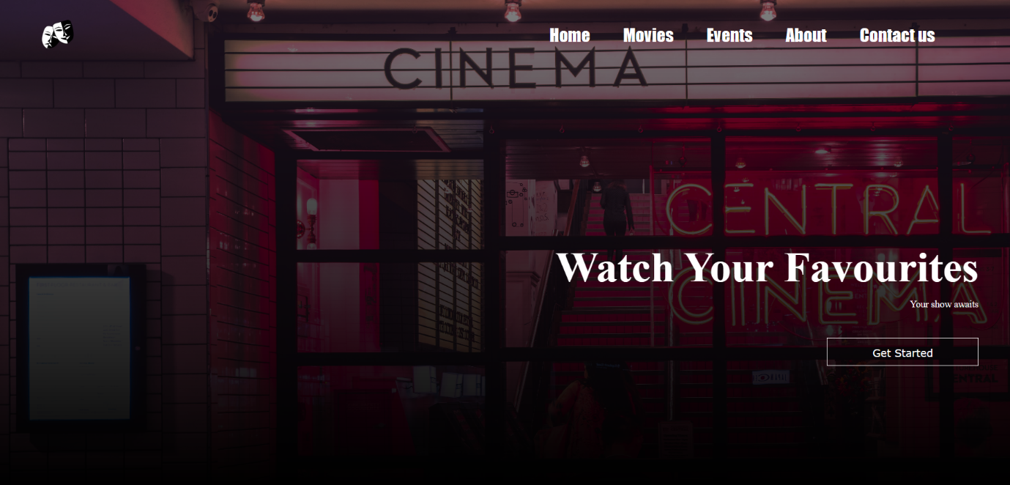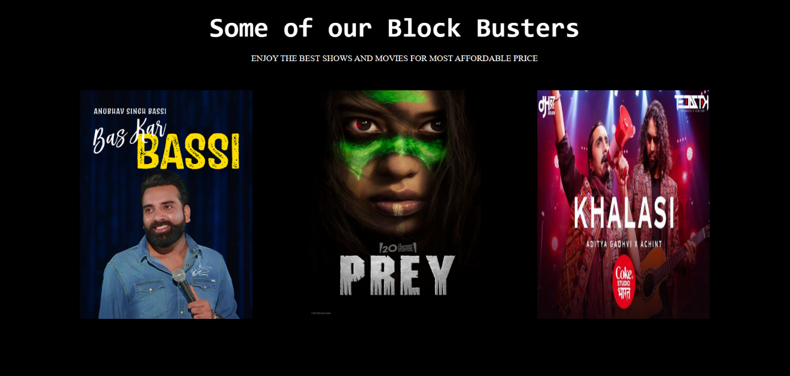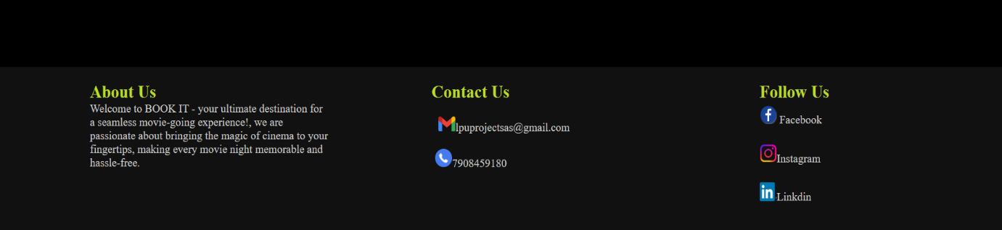

2.login and sign up page :

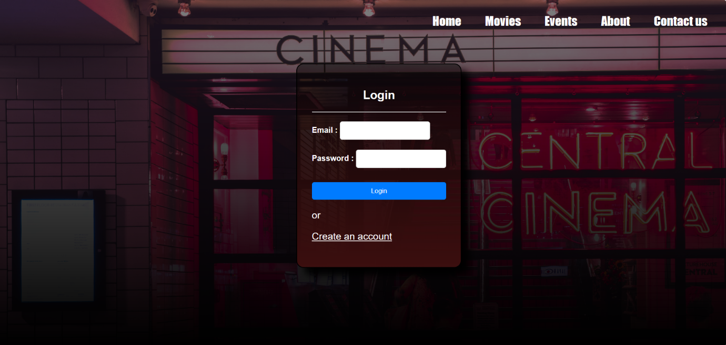

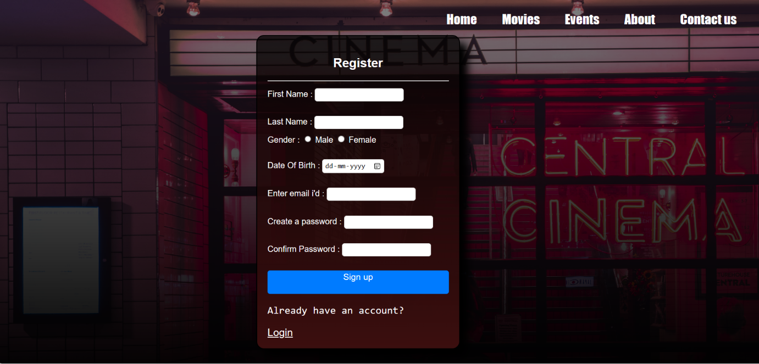

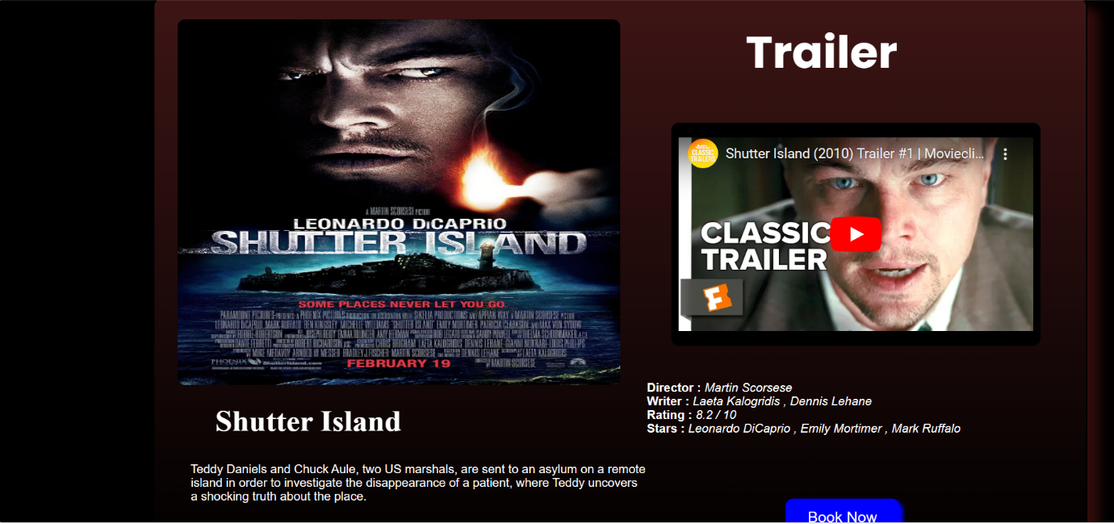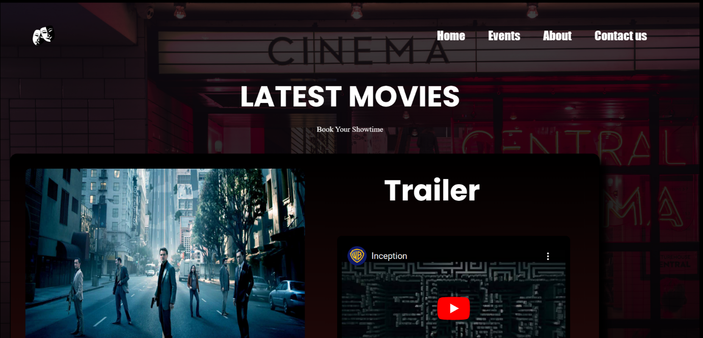3. movie booking page ; 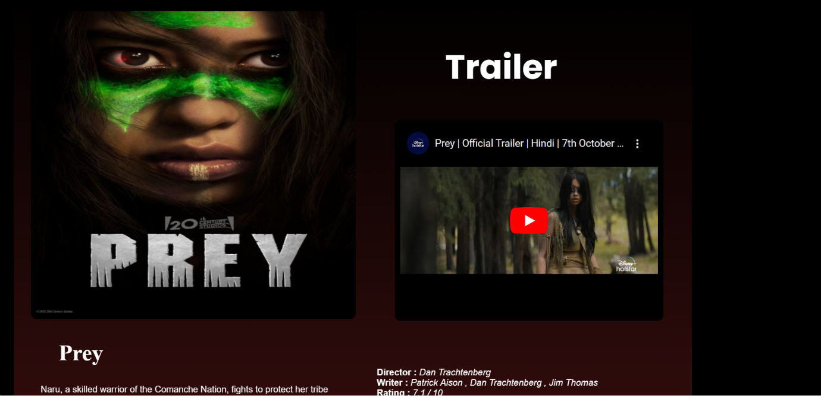

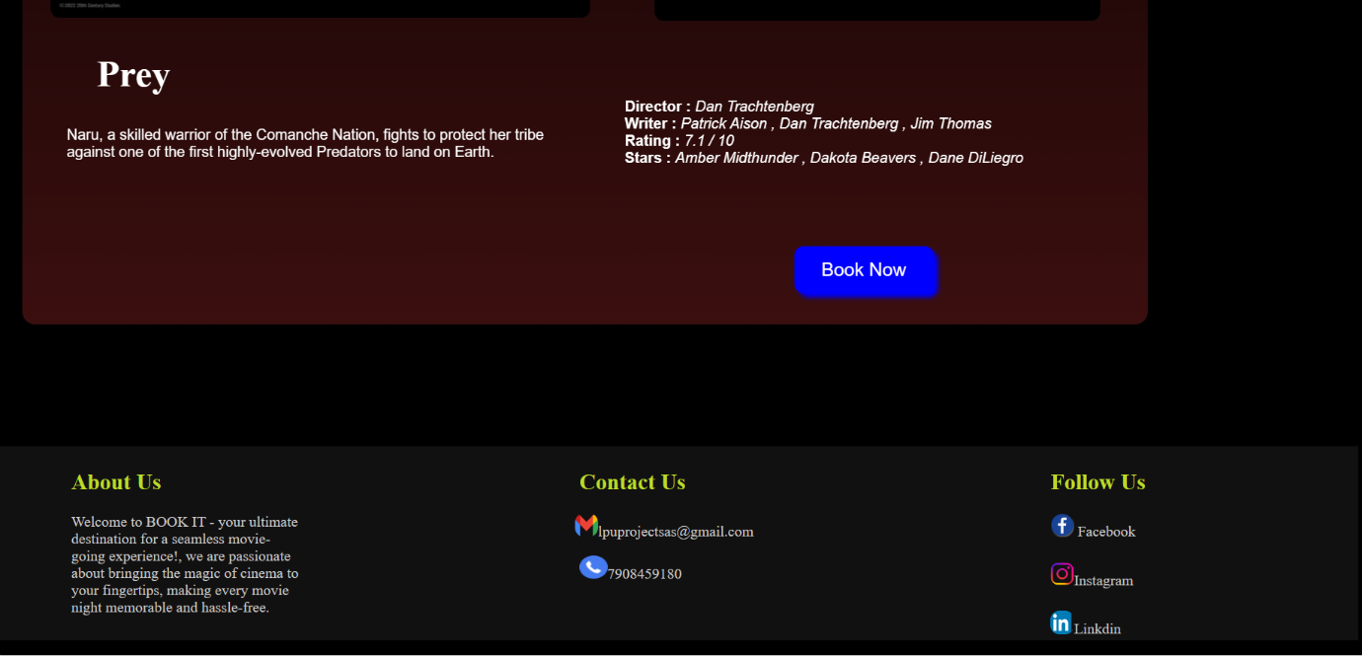

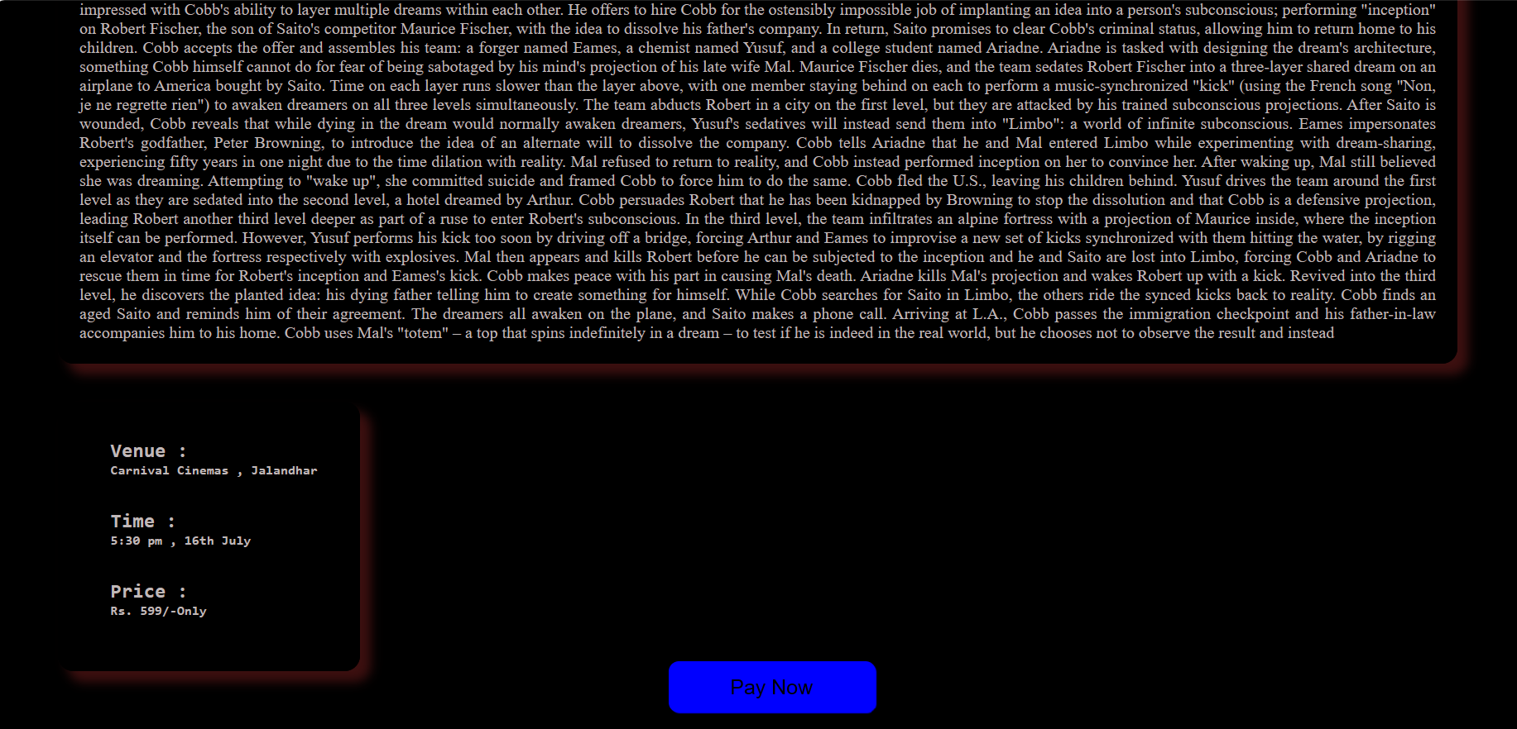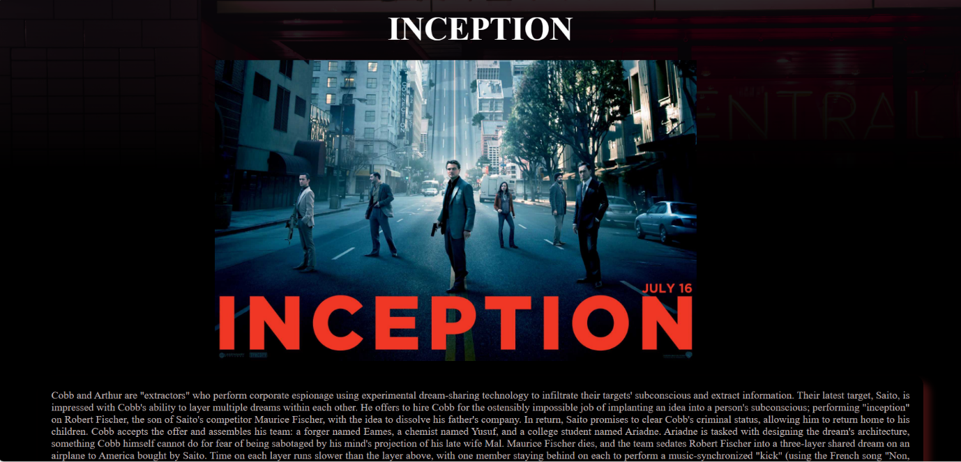4. movie description :

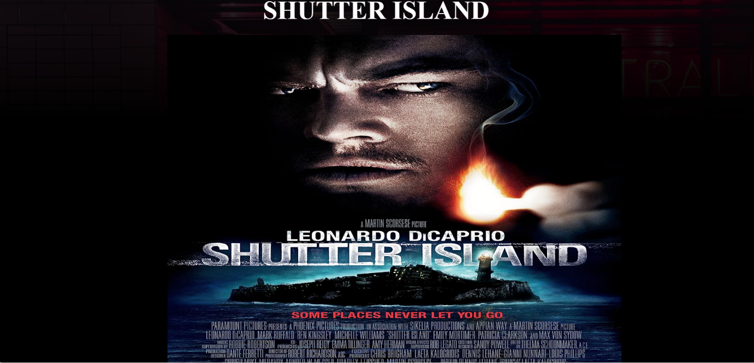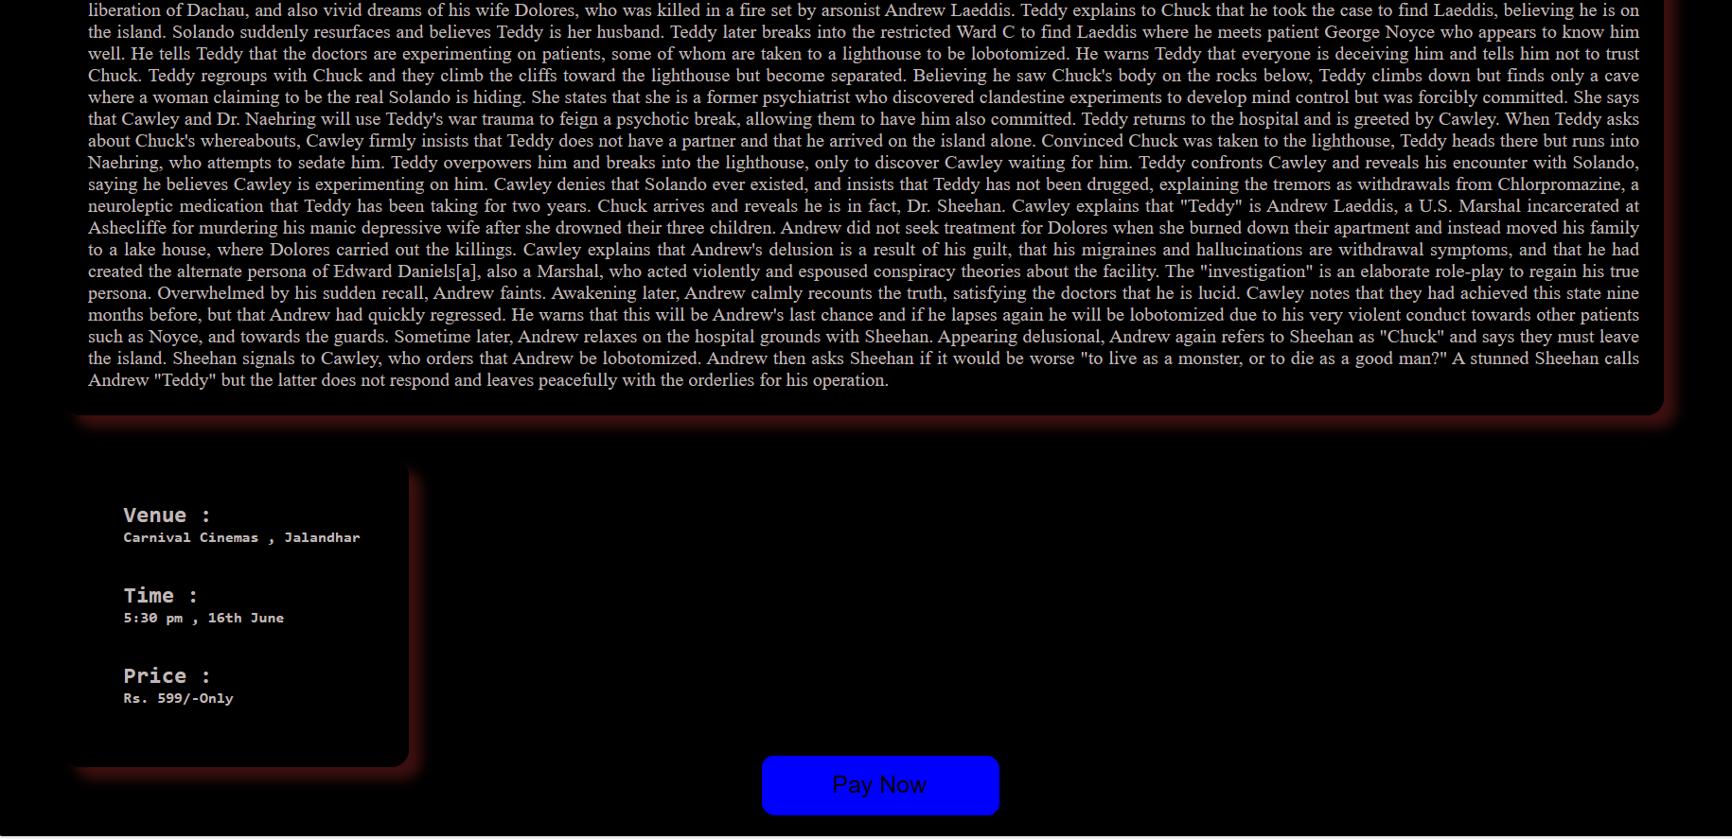

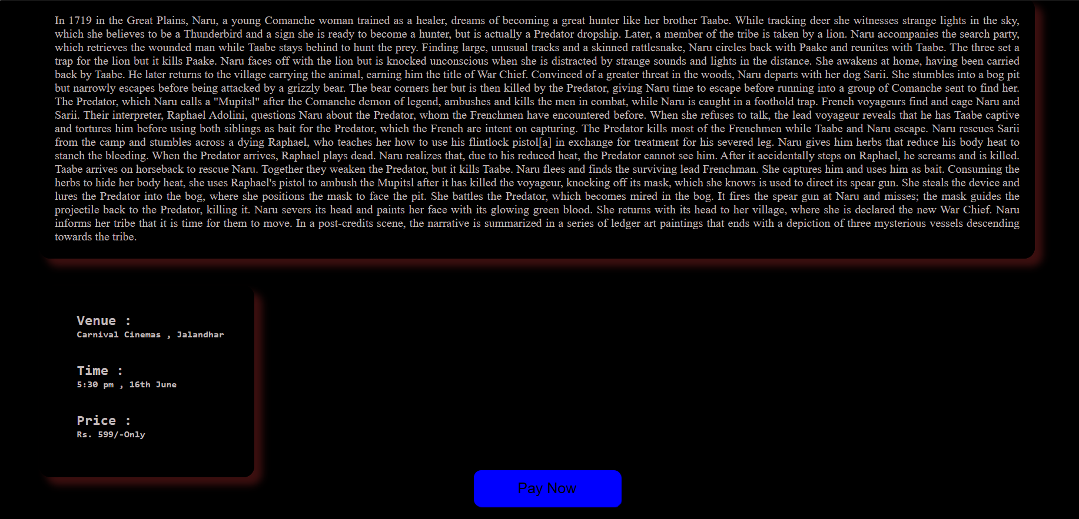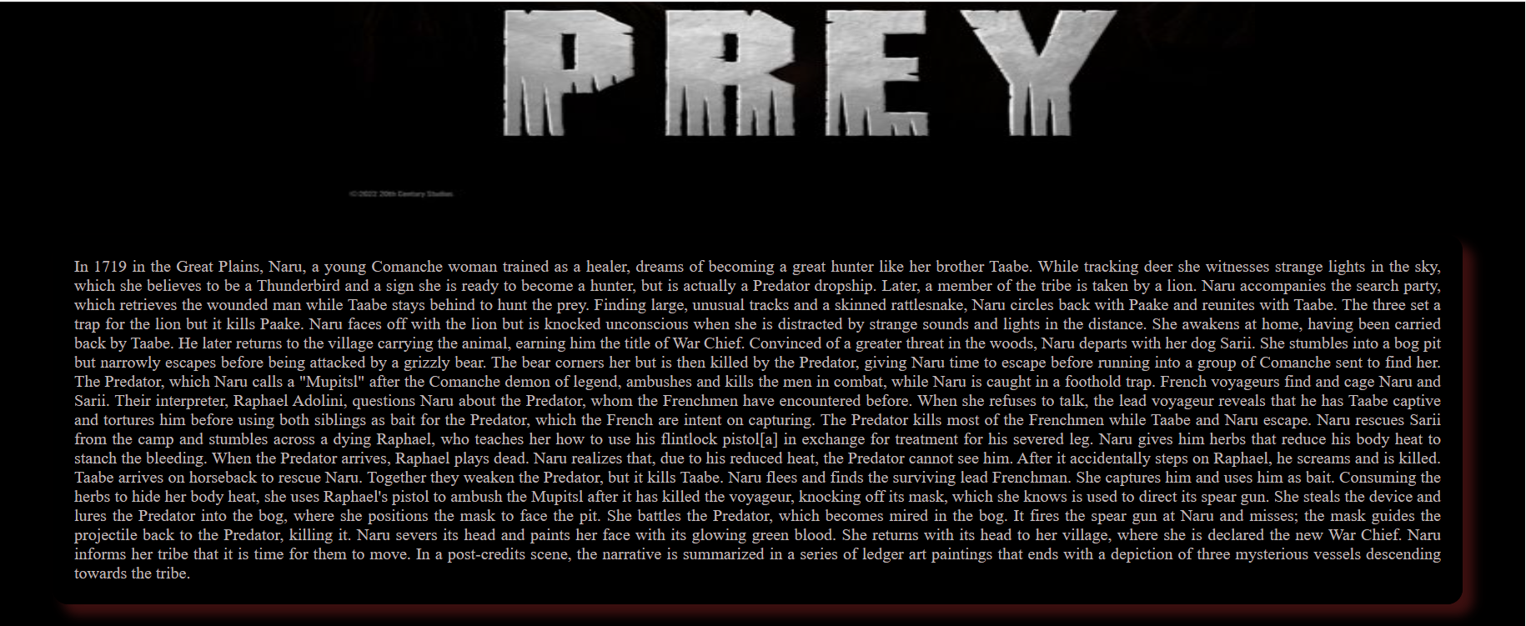

5.event ticket booking :

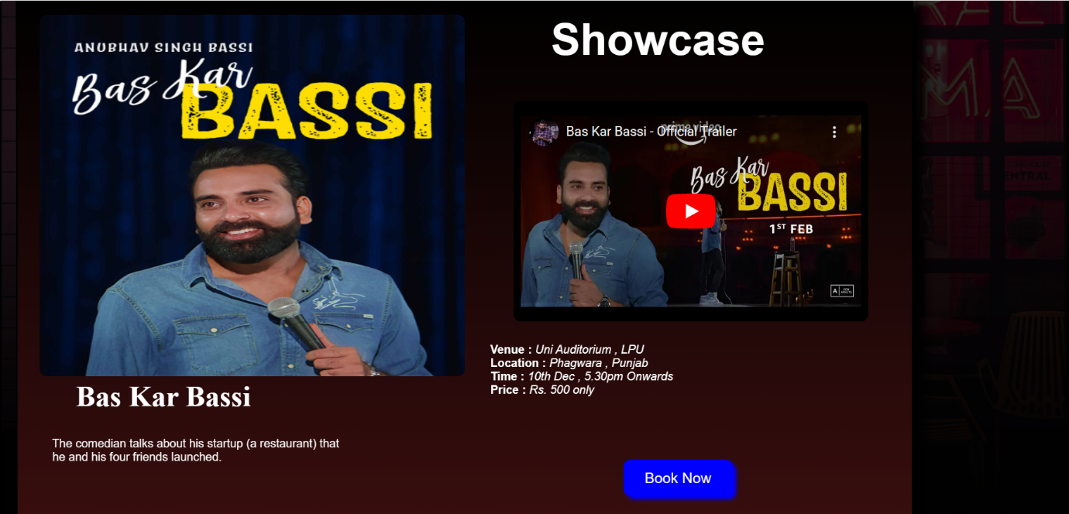

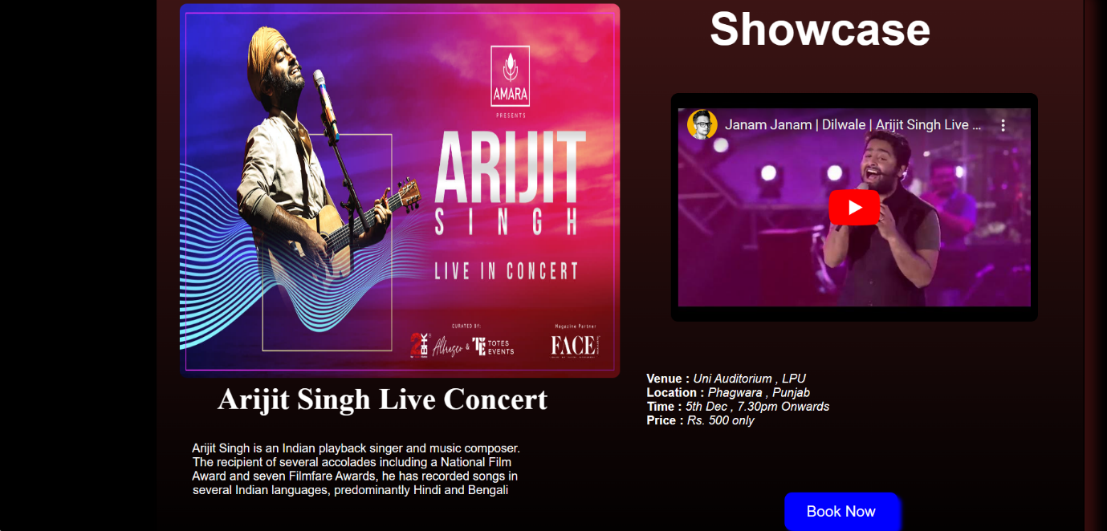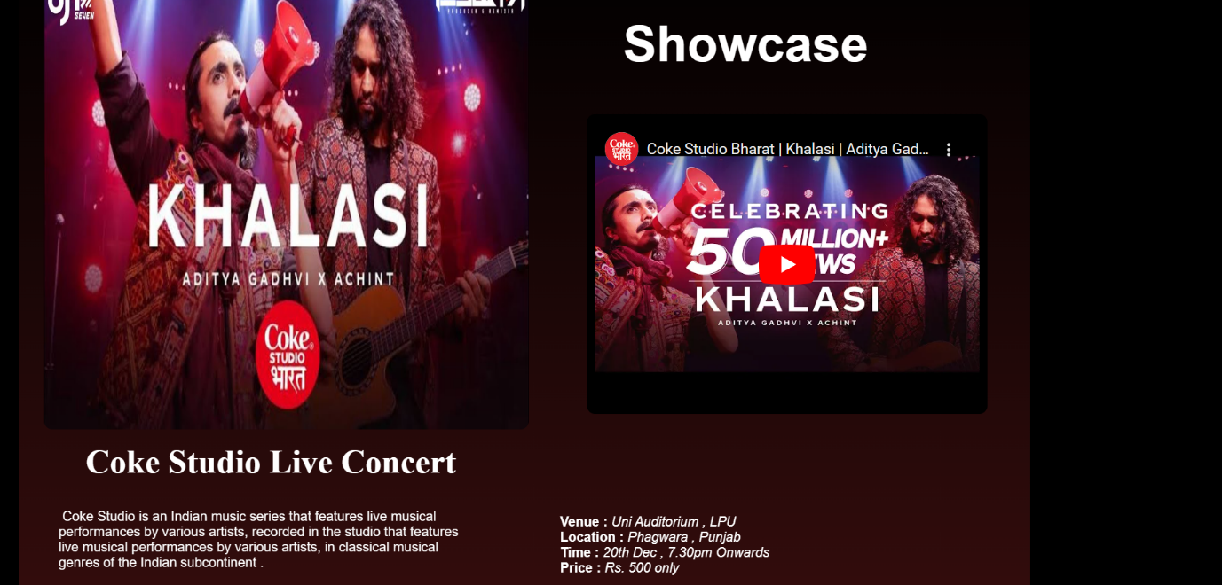

6.events description :

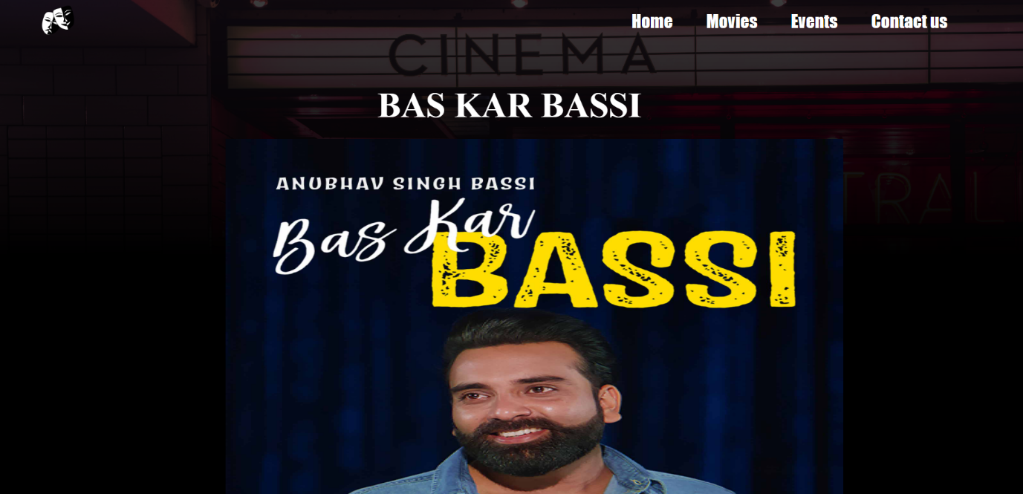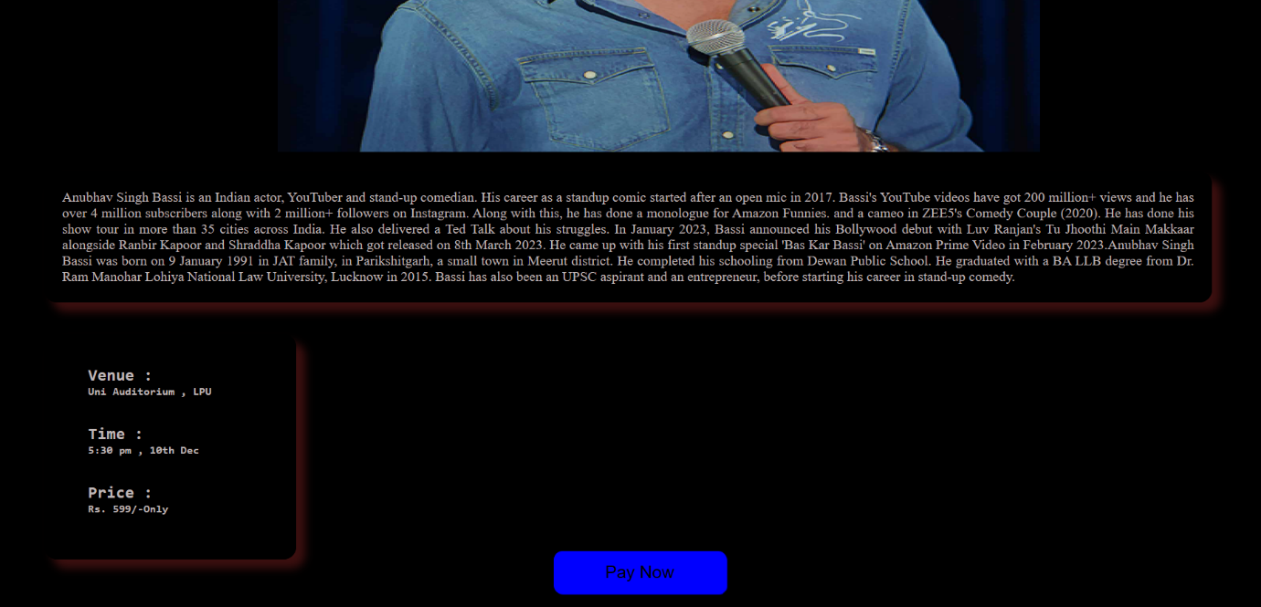

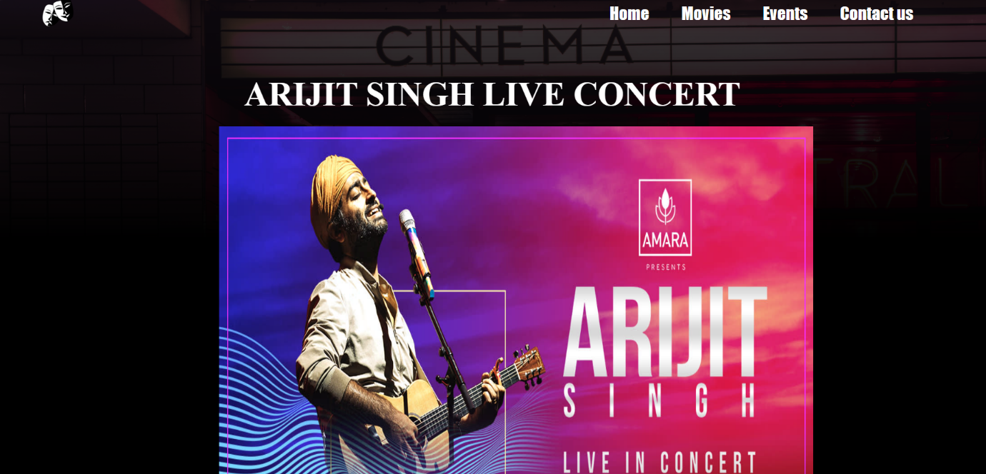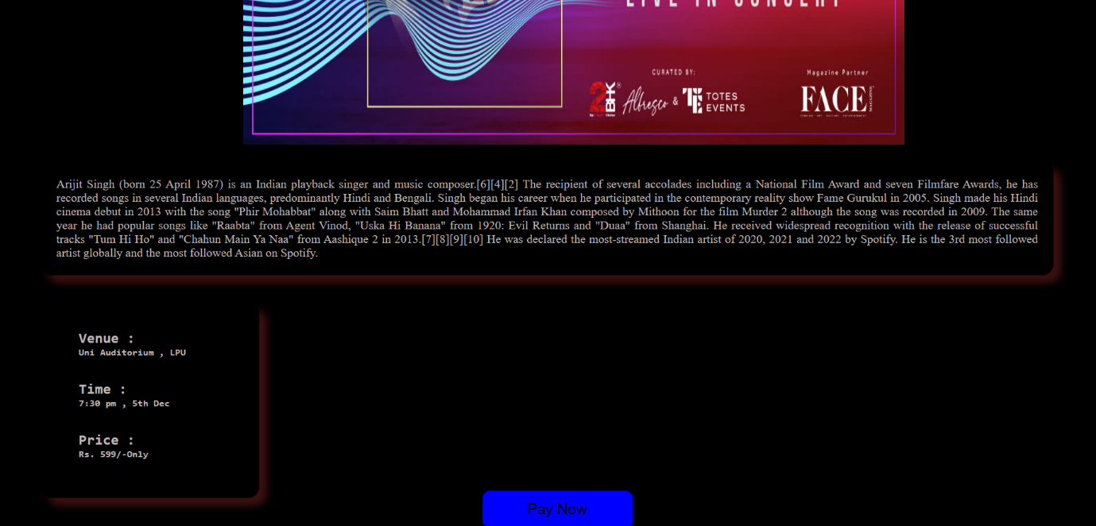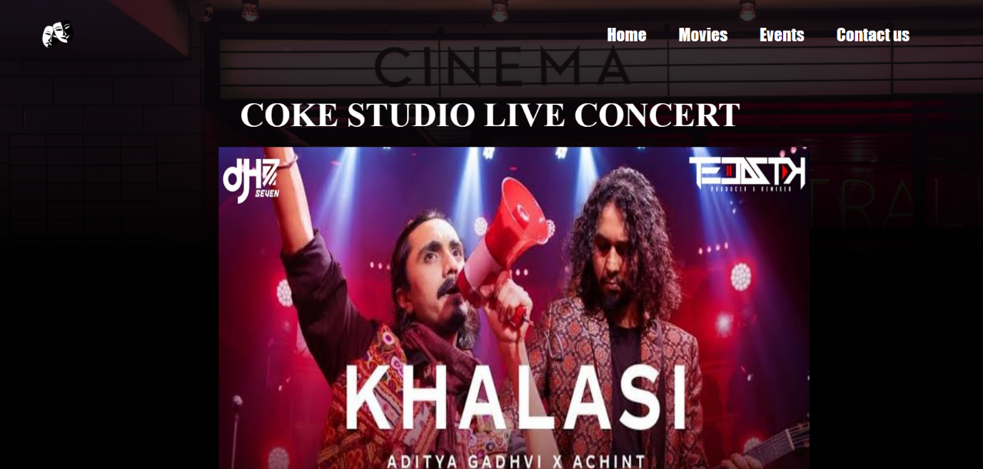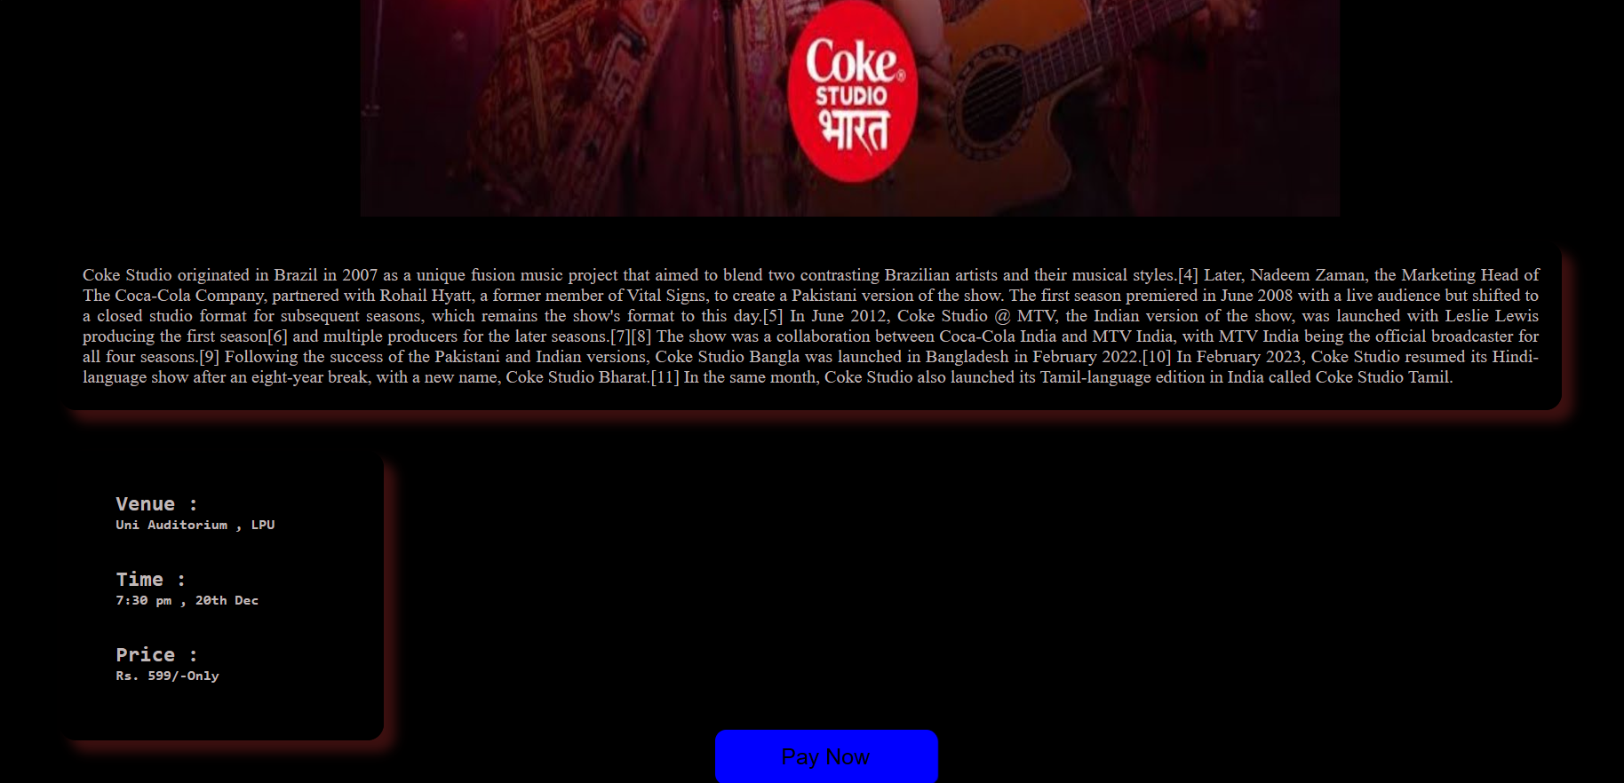

7.contact us page (all icons are clickable ):

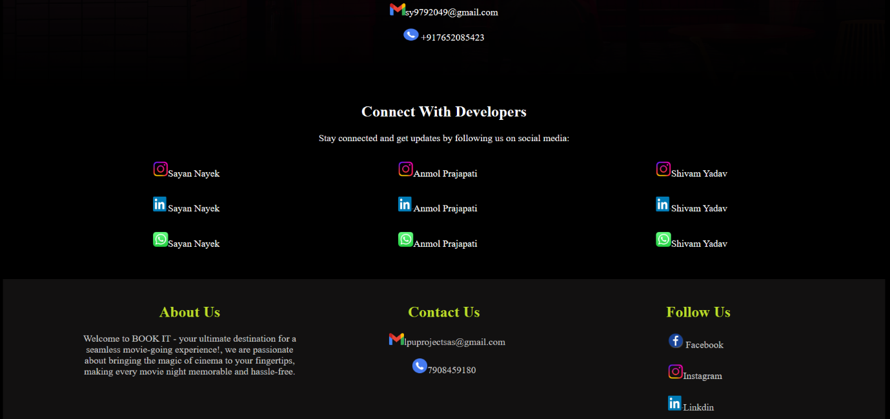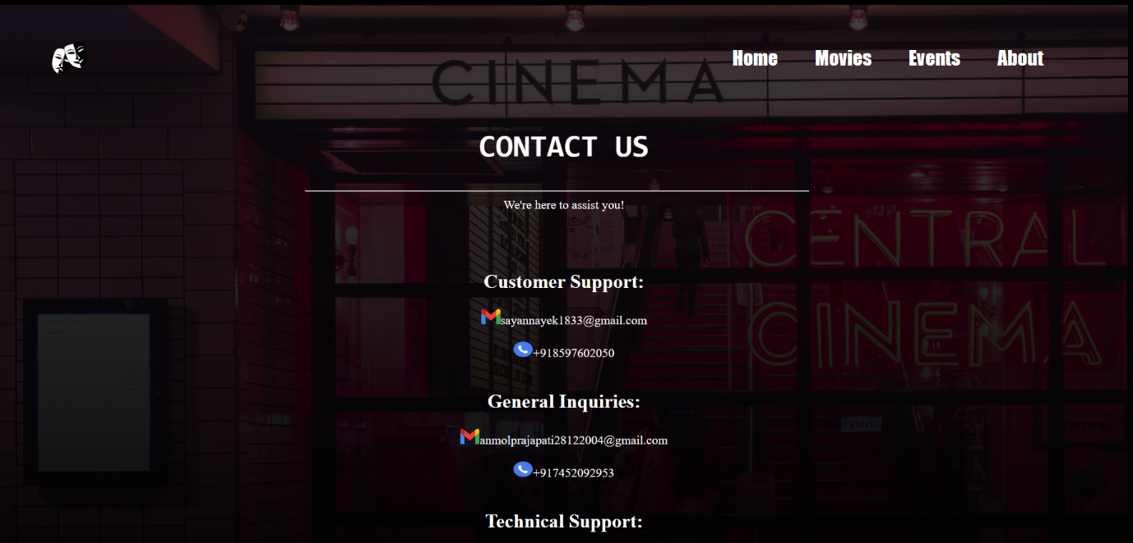

8.about us page :

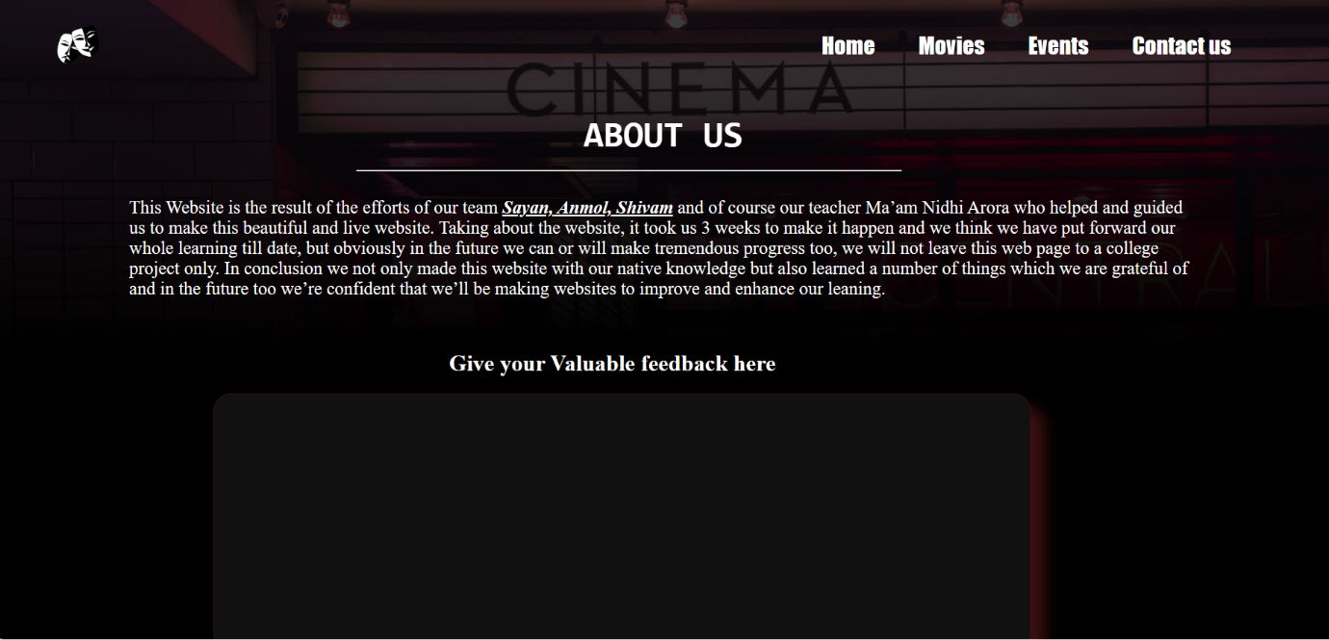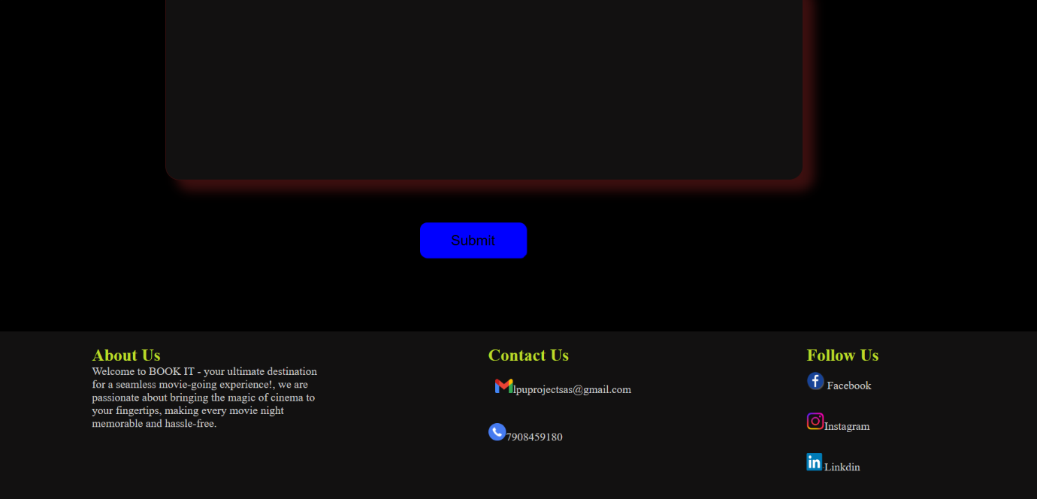

REFERENCES

Online Learning Platforms:

1. YouTube Tutorials:
   * Various YouTube tutorials were referenced for learning specific concepts related to HTML, CSS, and JavaScript. Individual channels and videos were consulted for guidance on topics such as responsive web design and animation.
2. W3Schools:
   * W3Schools served as a valuable online resource for quick reference and clarification on HTML, CSS, and JavaScript concepts.
3. Geeks for Geeks:
   * The Geeks for Geeks platform provided in-depth articles and tutorials on algorithmic concepts and problem-solving techniques.

Academic Resources:

1. CSE 326 Classes:
   * Lecture materials, assignments, and discussions from the CSE 326 course were crucial in understanding and applying web development principles. The guidance received in the classroom significantly influenced the project's direction.

CONCLUSION

In conclusion, our movie and show ticket booking webpage stands as a testament to the dedication, creativity, and technical prowess of Sayan, Shivam, and Anmol throughout the CSE 326 course assignment. By exclusively utilizing HTML and CSS, we embarked on a journey to master the fundamental elements of web development.

The careful structuring of every element using HTML provided a solid foundation, creating a logical hierarchy for content presentation. Meanwhile, the artful application of CSS breathed life into our design, ensuring a visually pleasing and user-friendly interface.

Drawing inspiration from online platforms like YouTube, W3Schools, and Geeks for Geeks, we enriched our understanding of HTML and CSS concepts, implementing industry best practices and innovative solutions. The academic guidance received in CSE 326 classes served as a guiding force, aligning our development decisions with rigorous standards and academic excellence.

This project not only allowed us to showcase our technical skills but also provided a platform for continuous learning and collaboration. As we present our movie and show ticket booking webpage, we invite you to experience the seamless blend of creativity and technology—a testament to the potential unlocked when HTML and CSS take center stage in web development.